**COMPLIANCE SUMMARY**

|  |  |  |  |
| --- | --- | --- | --- |
| RECOMMENDATIONS/  REMARKS | ACTION TAKEN BY HOST | % OF COMPLIANCE | EVIDENCES OF COMPLIANCE |
| 1. Consider reviewing your functional organizational chart to include more advanced library operations in response to the changing information landscapes. | **The University Librarian requested for the approval of Library Organizational Chart.** | **100%** | 1. **Approved Library Organizational Chart** |
| 2.The administration may encourage or support the acting Library Director to finish her Master’s degree in Library and Information Science through a scholarship grant in order for her to be qualified to such designation | **The University Librarian finished his Master’s Degree in Library and Information Science and currently pursuing his Doctorate Degree.** | **100%** | 1. **Copy of TOR for Masteral** 2. **Copy of Registration Form for Doctoral** |

|  |  |  |  |
| --- | --- | --- | --- |
| RECOMMENDATIONS/  REMARKS | ACTION TAKEN BY HOST | % OF COMPLIANCE | EVIDENCES OF COMPLIANCE |
| 3.An immediate review and update of the Library Manual maybe prioritized to consider the following:  a. online services  b. collection development  c. library policies  d. important parts of the manual like table of contents, etc. | **The University Librarian requested for Board Approval of Library Manual** | **100%** | **1.Indorsement of the Vice President for Student Services regarding the Approval of the Library Manual**  **2. Request for the Approval of Library Manual received by the Office of the Vice President for Student Services**  **3. Library Manual** |
| 4. Removal of pictures as these are more appropriate in your website, CAS, and promotion/ marketing | **The University Librarian updated the Library Manual** | **100%** | **Library Manual** |

|  |  |  |  |
| --- | --- | --- | --- |
| RECOMMENDATIONS/  REMARKS | ACTION TAKEN BY HOST | % OF COMPLIANCE | EVIDENCES OF COMPLIANCE |
| 5. Use of more appropriate format and presentation. | **The University Librarian updated the Library Manual** | **100%** | **Library Manual** |
| 6. Policies during this pandemic may be included. | **The University Librarian updated the Library Manual** | **100%** | **Library Manual** |
| 7. It is suggested that the Library Advisory Committee may be composed of representatives from selected colleges. Consider including faculty members who are not designated as Deans or Department Chairs as these personnel may have more administrative functions, and therefore may not be active as members of the Library Advisory Committee. | **The University Librarian requested for the Board of Regent’s approval on the Creation of the Library Advisory Board. Successfully, the Board Resolution 1054 s.2021 was released June 14, 2021** | **100%** | **1. Resolution No. 1054 Series 2021 Approving the Creation of Library Advisory Board**  **2. Administrative Committee Notice of Meeting related to Library Advisory Board**  **3. Request Letter to Library Advisory Board**  **4. Request Letter for endorsement** |

|  |  |  |  |
| --- | --- | --- | --- |
| RECOMMENDATIONS/  REMARKS | ACTION TAKEN BY HOST | % OF COMPLIANCE | EVIDENCES OF COMPLIANCE |
| 8. The administration may consider aligning the Library Department under the Vice President for Academic Affairs since the library’s main task is to support the curriculum or program. |  | **100%** | 1. **Board for Resolution** |

|  |  |  |  |
| --- | --- | --- | --- |
| RECOMMENDATIONS/  REMARKS | ACTION TAKEN BY HOST | % OF COMPLIANCE | EVIDENCES OF COMPLIANCE |
| 9. The administration may consider hiring more licensed Librarian to meet the Librarian ratio requirement of CHED and AACCUP. | **The University Librarian submitted a request letter for hiring of Librarians** | **95%** | 1. **Copy of Request Letter** |
| 10. It is strongly suggested that the library’s website be reviewed and updated especially with increasing need for online information services. Consider including other features and links that may provide faster and easier access of information by users outside the library and the university. | **The University Librarian updated and reviewed the library’s website** | **100%** | 1. **Updated Library Website** |
| 11. It is suggested that the library will prioritize the professional books per program. | **The Library acquired books for all the programs offered by the University** | **95%** | 1. **Purchased order** 2. **PRIV** 3. **List of Professional books (Parameter C)** |
| 12. It is suggested that a research focusing on the evaluation of the effectiveness of personnel, collection, services, physical facilities and other programs of the library be conducted. This may serve as a basis for planning library development programs. | **The University Librarian participated and presented in Research Colloquium** | **100%** | 1. **Certificates** 2. **Research Appointment Paper** |
| 13.Reiterating the previous recommendation to consider having a separate library building that can accommodate all library units and be easily accessible to all library patrons and house the growing collection including viewing room. | **The Infrastructure Management Office requested budget for the construction of the state-of-the-art library building approved by the NEDA.**  **The temporary main library is located at 2nd floor of SNAGAH while the construction of the University Library is on-process.** | **100%** | 1. **Evidence of budget for construction from the Infrastructure Management Office.** 2. **Library Floor Plan** |
| 14. Yearly library fees paid by students may be allotted solely for the development of the library, i.e. its collection, services, facilities, and other programs as planned by the library in coordination with the required offices. | **The University Librarian utilized the Library fees through continuous Acquisition of library material’s** | **100%** | 1. **Purchase Order** 2. **PRIV** |
| 15.It is highly suggested that the library will acquire a security gate system to safeguard the library resources. | **The University Librarian drafted Development plan** | **100%** | 1. **Copy of Development Plan** 2. **PPMP** |
| 16. The library is encouraged to engage more in associations that are active in promoting the development of librarians and libraries. | **The University Librarian requested for membership to PLAI and PAARL** | **100%** | 1. **Request Letter for Membership** 2. **Certificate of Membership** |
| 17.It is also suggested that attachments for accreditation purposes will include latest documents |  | **100%** | **Attachments for Accreditation.** |

|  |  |  |  |
| --- | --- | --- | --- |
| **RECOMMENDATIONS/**  **REMARKS** | **ACTION TAKEN BY HOST** | **% OF COMPLIANCE** | **EVIDENCES OF COMPLIANCE** |
| 1. Consider reviewing your functional organizational chart to include more advanced library operations in response to the changing information landscapes. | **The University Librarian requested for the approval Library Organizational Chart.** | **100%** | 1. **Approved Library Organizational Chart** |

**Library Organizational Chart**

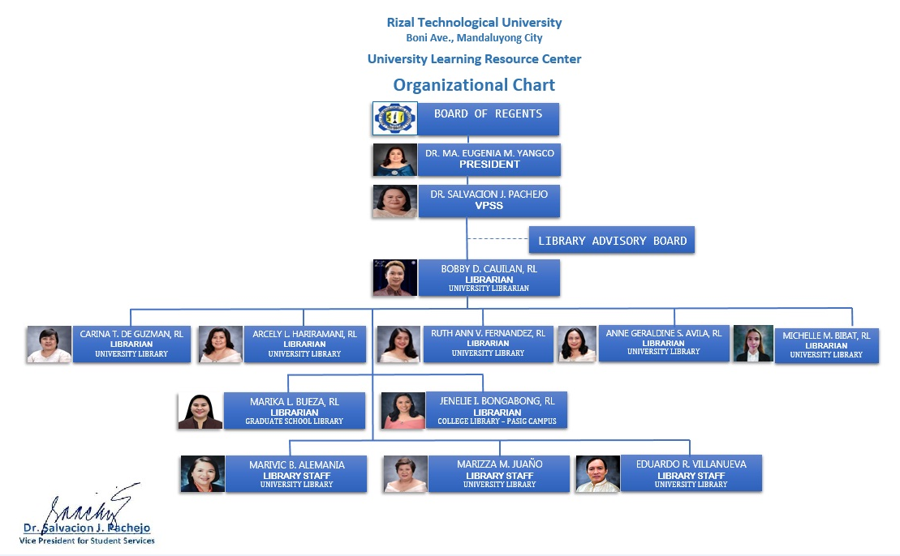

|  |  |  |  |
| --- | --- | --- | --- |
| RECOMMENDATIONS/  REMARKS | ACTION TAKEN BY HOST | % OF COMPLIANCE | EVIDENCES OF COMPLIANCE |
| 2.The administration may encourage or support the acting Library Director to finish her Master’s degree in Library and Information Science through a scholarship grant in order for her to be qualified to such designation | **The University Librarian finished his Master’s Degree in Library and Information Science and have units in his Doctorate Degree.** | **100%** | 1. **Copy of TOR for Masteral** 2. **Copy of Registration Form for Doctoral** |

**MLIS- Transcript of Records (TOR)**

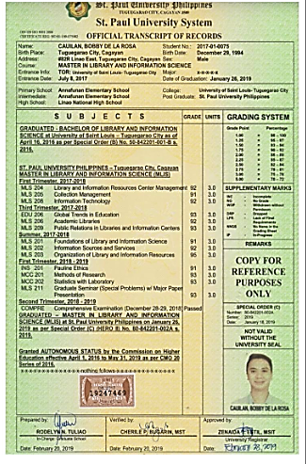

**Registration Form for Doctorate Degree**

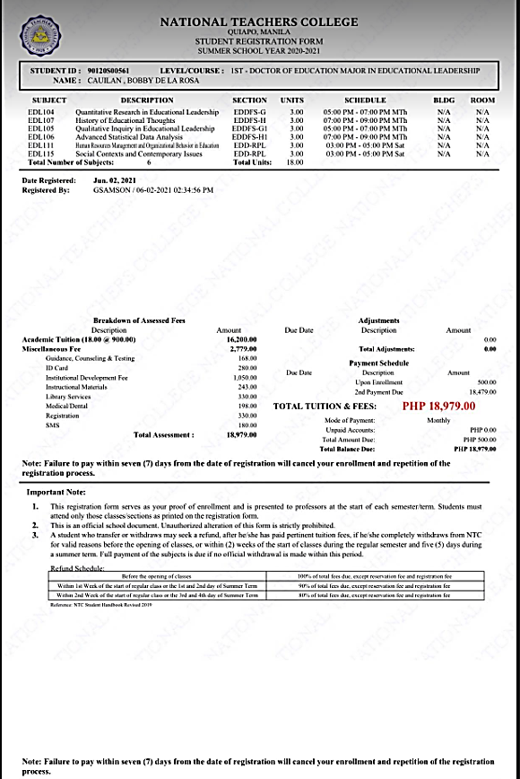

|  |  |  |  |
| --- | --- | --- | --- |
| RECOMMENDATIONS/  REMARKS | ACTION TAKEN BY HOST | % OF COMPLIANCE | EVIDENCES OF COMPLIANCE |
| 3.An immediate review and update of the Library Manual maybe prioritized to consider the following:  a. online services  b. collection development  c. library policies  d. important parts of the manual like table of contents, etc. | **The University Librarian requested for Board Approval of Library Manual** | **95%** | **1.Indorsement of the Vice President for Student Services regarding the Approval of the Library Manual**  **2. Request for the Approval of Library Manual received by the Office of the Vice President for Student Services**  **3. Library Manual** |
| 4. Removal of pictures as these are more appropriate in your website, CAS, and promotion/ marketing | **The University Librarian updated the Library Manual** | **95%** | **Library Manual** |
| 5. Use of more appropriate format and presentation. | **The University Librarian updated the Library Manual** | **95%** | **Library Manual** |
| 6. Policies during this pandemic may be included. | **The University Librarian updated the Library Manual** | **95%** | **Library Manual** |

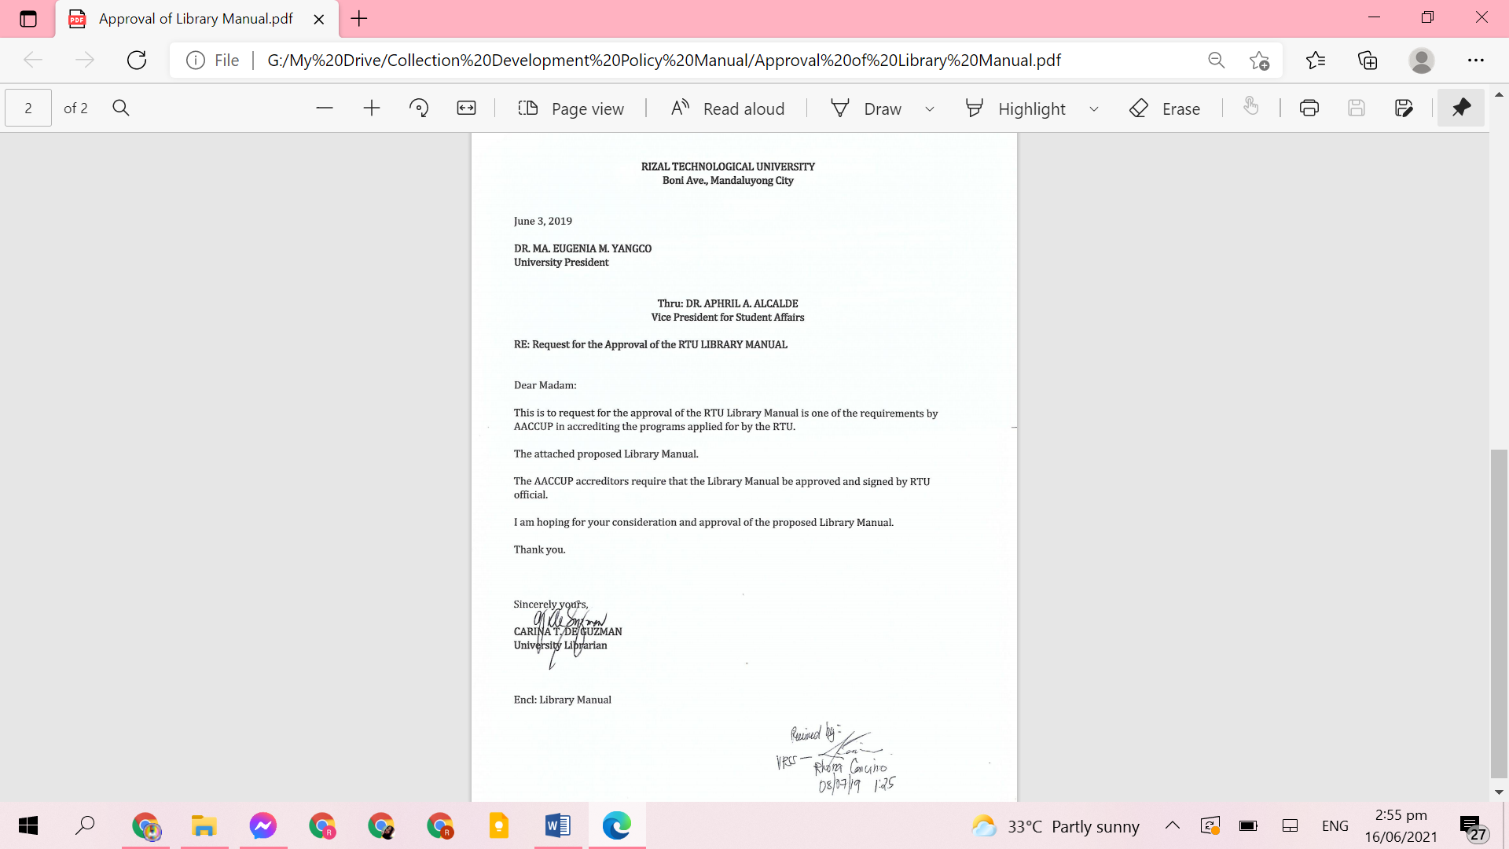

**Request Letter Regarding the Approval of Library Manual**

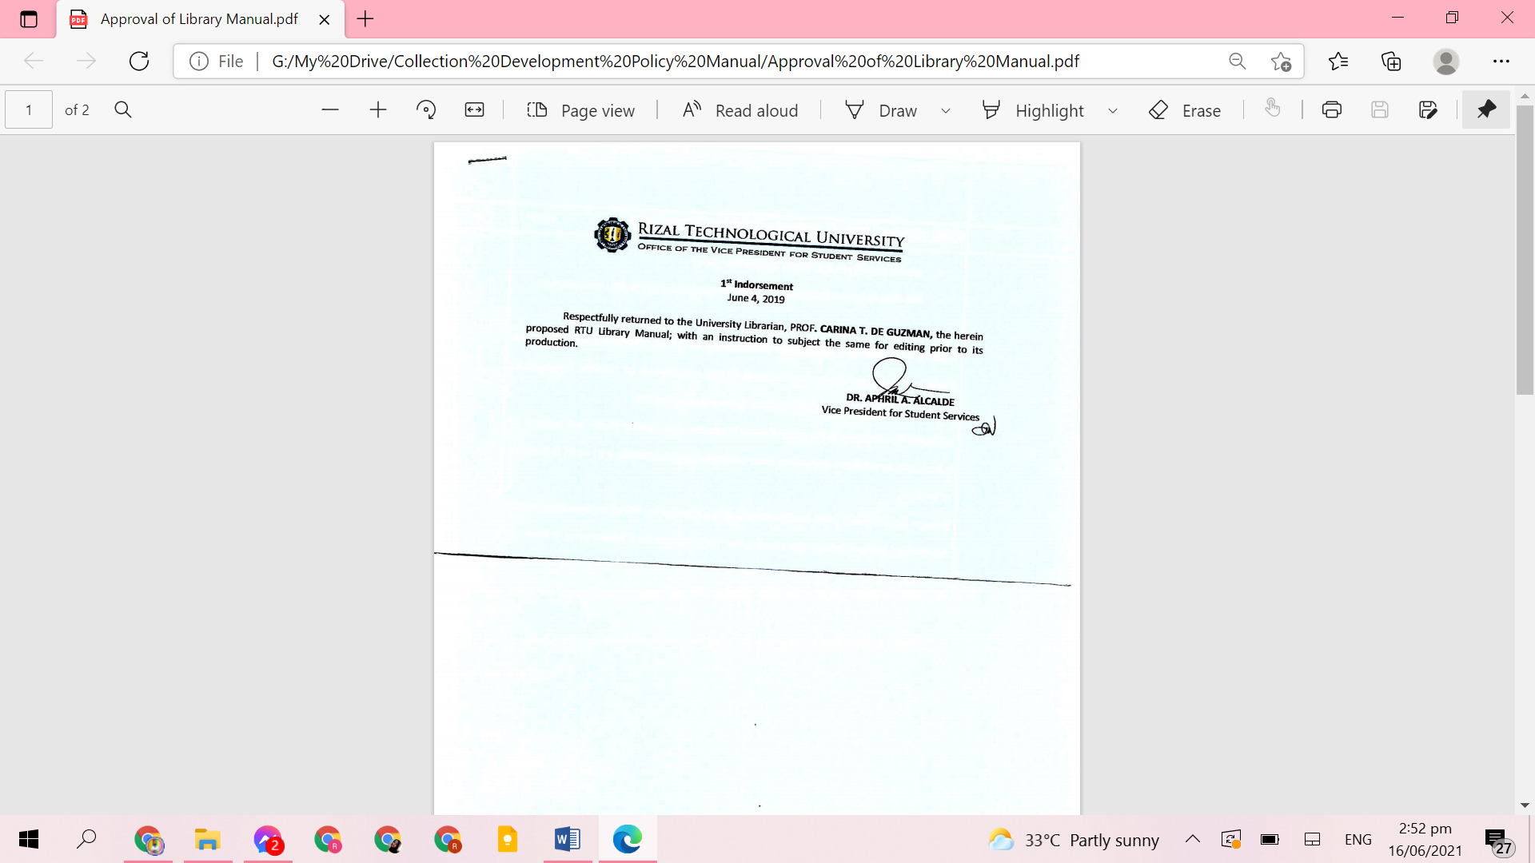

**Indorsement of Library Manual**



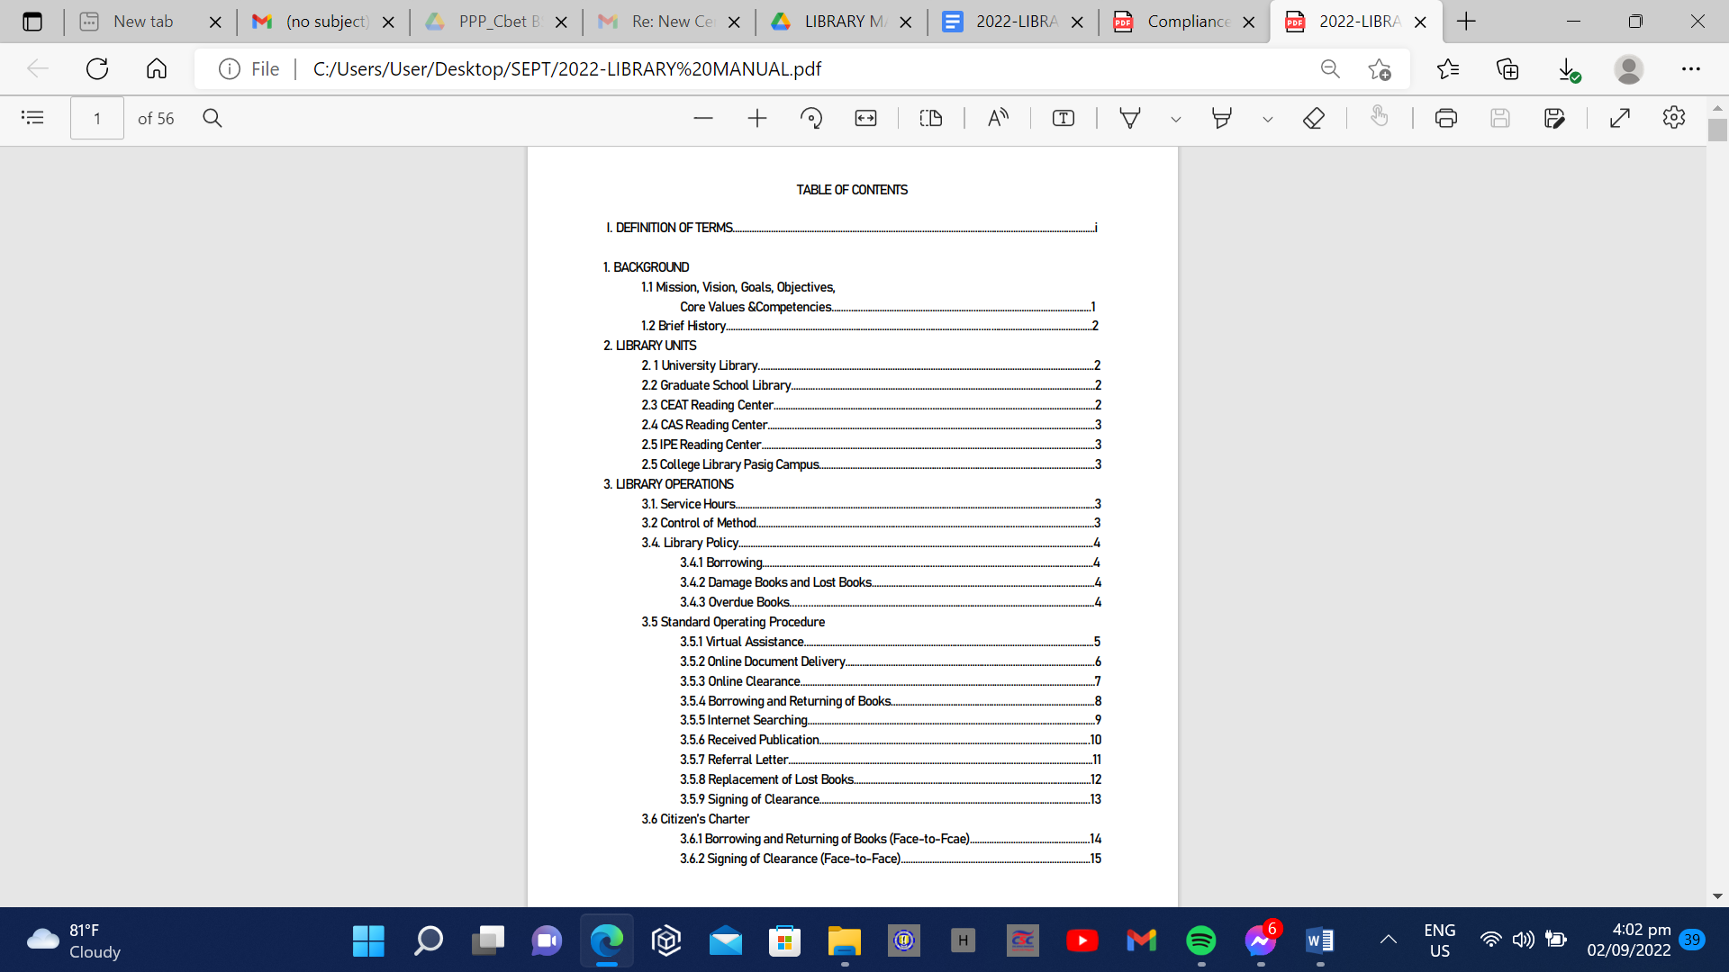

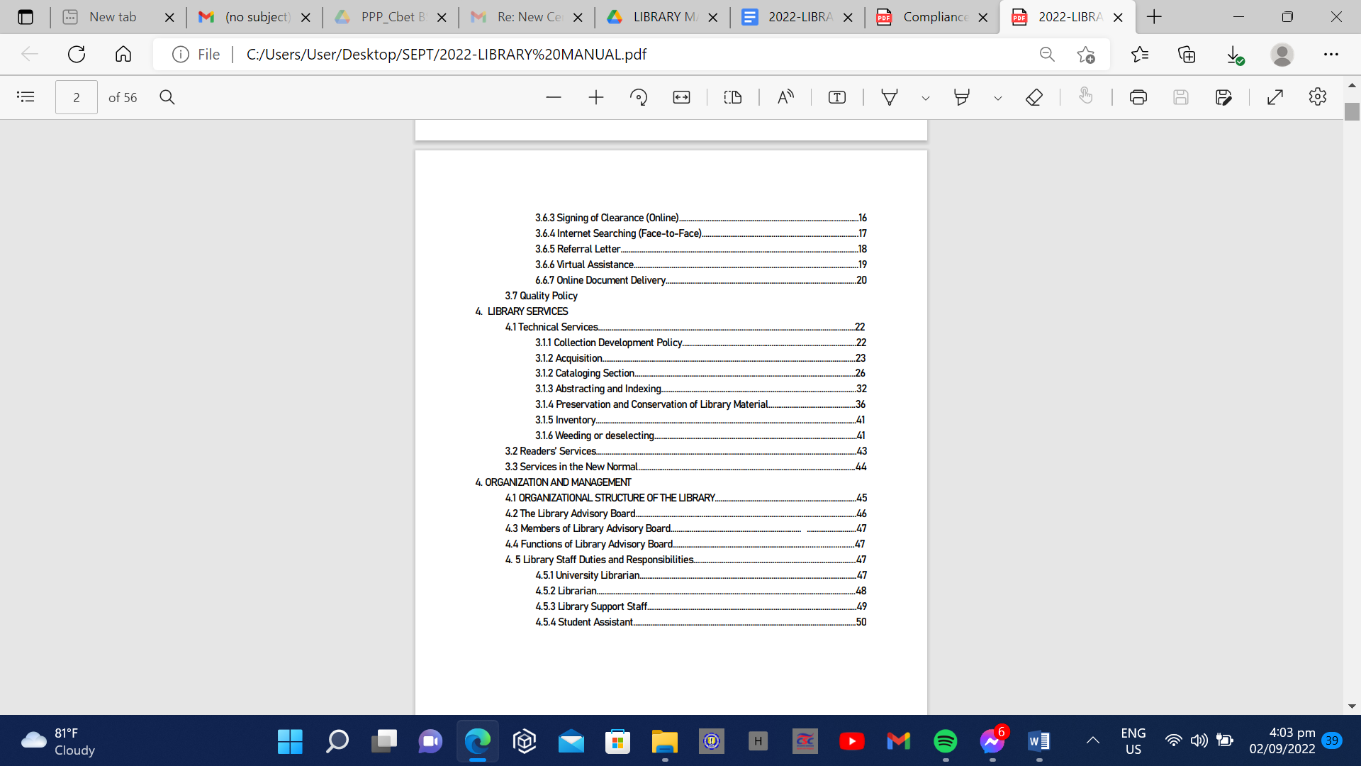

**I. DEFINITION OF TERMS AND ACRONYMS**

**Accession Number**– Refers to the unique number assigned to a bibliographic item in the order in which it added to a library collection, recorded in an accession record maintained of the technical services department.

**Accession Record**– Refers to a list of Bibliographic items added to a library collection in the order of their addition. Normally such a list includes the accession number, brief bibliographic identification, sources, and price paid for each item.

**Acquisition** – Refers to the process of securing materials for the library collection, whether by purchase, as gifts, or through exchange programs.

**Bindery** – Refers to books that need repair and loose issues of journals that are combined or bound into a single volume sent out of the library system to a company which binds them.

**Call Number** - Refers to the combination of numbers and letters that provide a unique description of each item in a library collection.

**Card Catalog** - Refers to a card file, arranged by author, title, and subject, listing all items owned by a library.

**Cataloging** - Refers to the process of creating entries for a catalog.

**Charging** – Refers to the lending of information resources to library users.

**Circulation Books** – Refer to stack books which can be borrowed for longer period than overnight

**Circulation desk** – Refers to location or area in each library where you check out, return or renew items, ask about missing items, or inquire about fines.

**Citation** – Refers to a reference or footnote to an item; it contains the author, title, date of publication and any information needed to locate the item.

**Classification Scheme** - Refers to a classification system which uses numbers and/ or letters, to represent the subject content of materials.

**Clearance-** The

**Collation** – Refers to thorough examination of all parts of the books returned by borrowers, to find out missing pages, mutilated parts, and any other damages.

**Collection** - Refers to the resources in any format that the library acquires or provides access to including online resources accessible via the library webpage.

**Conservation** - Refers to the aspect of preservation activity which implies the active use of preventive measures, or processes of repair of damaged materials to ensure the continued existence of individual library materials.

**Copyright** - Refers to the legal right to control the production, use and sale of copies of a literary, musical, or artistic work.

**Cross References** – Refer to a word or heading that directs you from one part of a book, catalog, or index to another part.

**Data Pacific–** University-wide system

**Discarded** - Refers to item that are no longer in the library collection.

**Discharging** - Refers to the cancelling out the borrower’s responsibility for information resources.

**Due date** - Refers to the date by which borrowed books and materials should be returned. To extend the loan period for materials, the item should be renewed before due date so that fines are not incurred.

**Exchange** - Refers to the process by which books or other library materials as manuscripts, periodical, maps, prints, photographs, electronic resources are exchanged between the PSU and another library, institution or organization.

**E-Resources** - Refer to any work encoded and made available for access through the use of computer.

**Filipiniana** - Refers to the publication dealing with the Philippines in whatever language they may be written and place where they may have been printed.

**Fines** - Refer to the amount of money which is paid by the borrower if materials are not returned on time.

**Gift** - Refers to Library materials offered by a known person or persons, corporation, institution, or agency that RTU may choose to accept or reject.

**Holdings** - Refers to the materials owned or held by a library.

**Index** – Refers to points to where information can be found.

**Internet –** Refers to electronic communications network that connects computer networks and organizational computer facilities in various places in the world.

**ISBN** – Refers to (International Standard Book Number) A four-part, ten-character code given a book before publication as a means of identifying it concisely, uniquely, and unambiguously.

**ISSN** – Refers to (International Standard Serial Number) The International numerical code that identifies concisely, uniquely, and unambiguously a serial publication.

**Issue** - Refers to a single uniquely numbered or dated part of a periodical or newspaper.

**Journal** – Refers to type of periodical which contains signed scholarly articles. Journals are usually published by academic or association presses and include bibliographies.

**Library Advisory Board** - Refers to the body or a person that deals with library activities. They also play an effective and important role to run the library efficiently.

**Library Staff** – Refers to serve as the primary source for the Library

Administration in planning personnel policies and procedures of the library.

**Library Student Assistant** - Assists staff with daily routine library operations.

**Linkages** – Refers to organized group of people, institutions/agencies and

philanthropic individuals with whom the College establishes and strengthens connection with for augmenting resources.

**Newspaper** - A serial issued at stated, frequent intervals containing news, opinions, advertisements, and other items of current, often local, interest.

**OPAC - (Online Public Access Catalog)**- A computerized catalog of books and other items in the library Overdue- Material which is not returned to the library by its due date is considered overdue.

**Periodical** – Refers to all materials published at regular intervals and intended to be continued indefinitely.

**Photocopying** – Refers to a process where a usually printed material is copied and formed by the action of light usually on an electronically charged surface.

**Preservation** – Refers to all the managerial and financial considerations, including storage and accommodation provisions, staffing levels, policies, techniques, and methods involved in preserving library and archival material and the information contained in them.

**Professional Librarians** - Refer to someone who has a degree in Library and

Information Science.

**Publication** - A book, periodical, musical score, and etc., that has been “brought before the public”; in other words, a work that has been printed and distributed.

**Public services** – Refer to those library activities where direct contact with the costumer occurs on a daily basis.

**Readers Services** - Refers to the section of the library that provides resources to the library patrons for home reading in and outside the library.

**Reference Desk** – Refers to location in each library where you can get help in using the library and received answers to your questions.

**Reference materials** - A selection of library materials used by reference librarians and information assistants to help people find information or do research.

**Reference collection** - Contain many sources of information, such as dictionaries, directories, almanacs, encyclopedias, atlases, and statistical compilations. They may also have bibliographies, indexes, and abstracts. Reference materials usually do not leave the library.

**Reference process** – Refers to the whole transaction between the inquirer and the librarian ending up with the solution to the inquirer’s problem.

**Renewal** – An extension of the loan period for a charged library materials. As long as no one else requests the book, renewals are unlimited.

**Reserved Materials** – A selection of specific books, periodical articles and other materials which faculty have indicated that students must read for a particular course.

**Selection** – Refers to process of choosing appropriate information resources that best serve the needs of the College constituents.

**Selective Dissemination of Information-** The service given to the library clients to keep them informed of the new resources on specific topics related to their needs and interest.

**Serials** - Refers to the journals or newspaper in electronic or hard-copy format.

**Shelf list** - The part of RTU library’s card catalog which is arranged by Dewey Decimal Call number rather than by author or title.

**Subject Heading** - A term or phrase used in indexes and library catalogs to describe the content of library materials in a standardized way.

**Subject Reserve Books** - Refer to books placed on reserve to give a fair chance of use by each student enrolled in the subject.

**Technical Services** - Refer to the behind-the-scene activities that a library undertakes to process library materials loaned for the Users.

**Virtual Assistance-** Assistance given to library clients which answers their queries through facebook page and email.

**Weeding** – Refers to the systematic review of the collection in search of materials that can be withdrawn and discarded or moved to an alternate storage.

**I. BACKGROUND**

**I. 1 MISSION, VISION, GOALS, OBJECTIVES, CORE VALUES AND COMPETENCIES**

RIZAL TECHNOLOGICAL UNIVERSITY

MISSION

Prepare students to create their future in knowledge-driven and culturally diverse society.

VISION

A prominent University recognized for its commitment to innovative programs in addressing society's challenges.

UNIVERSITY LEARNING RESOURCE CENTER

GOALS

To provide better opportunities in enhancing scholastic growth of students and faculty members through acquisition of instructional materials, modern facilities, equipment, and provision of efficient and effective Services to its clientele.

OBJECTIVES

1. Strengthen collection program policies, guidelines and procedure in the acquisition of quality and recent books, and electronic materials through purchase, gifts, and donations of exchange of publications.

2. Upgrade the collection of books, and institute deselecting program for outdated books.

3. Organize print, non-print, and electronic sources of information for immediate use of patrons.

4. Extend Library services and related activities to barangays, Library associations, and other sectors.

5. Conduct Research for the enhancement of Library Service and development of the library staff, as well as customers.

1

**I.2 BRIEF HISTORY**

In 1969, the University Library started as a College Library at the Pasig Campus. In 1978, by virtue of the Presidential Decree No. 1341 – A, RTC was converted into a State College; in October 1998 into a State University (Republic Act No. 8365). Since then, the library has grown and was divided into four (4) units: Main Library, Graduate School Library, Laboratory High School Library, and the College Library at the Pasig campus. Library by College (CAS, CED, CBET, CEIT, and IPE RC) were established to accommodate more clientele. Hence, these libraries are the components of what we call now as the University Library

In 2013, Office Order No. 701 –Devolution of Library Services was issued wherein the library services of all library units are under the direct supervision of the Academic Dean in the colleges where they belong.

The RTU Libraries is an automated integrated library system using Data Pacific. It is adopting an open-shelf service system. Its materials are arranged according to Dewey decimal classification Scheme. It caters to students and faculty member as well as, visitors-researchers from other libraries and agencies. All Library units are under the direct supervision of the Vice-President for Student Services in coordination with the Deans of respective colleges.

In 2018 Office Order No. –Designation of University Librarian was issued whereas Ms. Carina T. De Guzman will be responsible in the overall library operations.

At present, Special Order No. 25 s. 2021, Designation as Acting University Librarian was assumed by Ms. Ruth Ann Velasco.

**2. LIBRARY UNITS**

**2. 1 University Library**

The University Library is located at the 2nd floor of SNAGAH left and right wing.

It caters all enrolled students, employees, alumni, and outside researchers with referral letter. It has baggage area, circulation section, filipiniana section, reference section, theses section, periodical section, internet section, reading area, library staff area. It has 230 seating capacity.

**2.2 Graduate School Library**

The Graduate School Library is located at the 4th floor of RND Building.

It caters students and faculty members of the Graduate School. It has baggage area, circulation section, filipiniana section, reference section, theses section, periodical section, internet section, reading area, library staff area. It has 60 seating capacity.

2

**2.3 CEAT Reading Center**

The CEAT Reading Center is located at the 3rd floor Multipurpose Building.

It caters students and faculty members of the College of Engineering, Architecture and Technology. It has baggage area, circulation section, filipiniana section, reference section, theses section, periodical section, internet section, reading area, library staff area and discussion room. It has 150 seating capacity.

**2.4 CAS Reading Center**

The CAS Reading Center is located at the 3rd floor MAB Building.

It caters students and faculty members of the College of Arts and Science. It has baggage area, circulation section, filipiniana section, reference section, theses section, periodical section, internet section, reading area, library staff area. It has 70 seating capacity.

**2.5 IPE Reading Center**

The IPE Reading Center is located at the 5th floor MAB Building.

It caters students and faculty members of the Institute of Physical Education. It has baggage area, circulation section, filipiniana section, reference section, theses section, periodical section, internet section, reading area, library staff area. It has 40 seating capacity.

**2.6 College Library Pasig Campus**

The College Library Pasig Campus is located at the 5th floor MAB Building.

It caters all enrolled students, employees, alumni, and outside researchers with referral letter of Pasig Campus. It has baggage area, circulation section, filipiniana section, reference section, theses section, periodical section, internet section, reading area, library staff area. It has 125 seating capacity.

**3. LIBRARY OPERATIONS**

**3. 1 SERVICE HOURS:**

The library serves from Monday to Saturday with minimum of 60 hours per week. No noon break policy is being observed.

**3.2 METHOD OF CONTROL**

3.2. Students and other clients have to log-in to the electronic patron attendance using their Digital Identification Card.

3.2.2 Students and other clients are required to deposit their things except their valuables such as wallet, cellphone, tablet, laptop, and others at the bag counter.

3

3.2.3 Visitor-researchers are required to present Referral given by the Librarian from the school they are studying.

**3.3 LIBRARY POLICY**

**3.3.1. Borrowing**

3.3.1.1 Fulltime faculty members are allowed to borrow maximum of three (3) books for a period of one (1) week.

3.3.1.2. Part-time faculty members are allowed to borrow maximum of three (3) books for a period of two (2) hours only. They are not allowed for overnight use.

3.3.1.3. Graduate students are allowed to borrow maximum of three (3) books for a period of one (1) week.

3.3.1.4 Undergraduate students are allowed to borrow maximum of three (3) books for a period of three (3) days.

3.3.1.5 Reserve, reference, thesis and dissertation collection are for library use only.

3.3.2 Damaged Books and Lost Books

3.3.2. Damaged, vandalized, and loss of borrowed books are subjected for replacement by same author, title, copyright date and physical description (bound, newsprint, reprint). If out of stock/print, it must be replaced by similar subject but of current copyright date.

3.3.3 Overdue Books

3.3.3.1.Library borrowers are subject to pay fines amounting to twenty pesos per day (Php 20.00) including Sundays and Holidays for overdue books.

**3.4. STANDARD OPERATING PROCEDURE**

3.4.1 Virtual Assistance

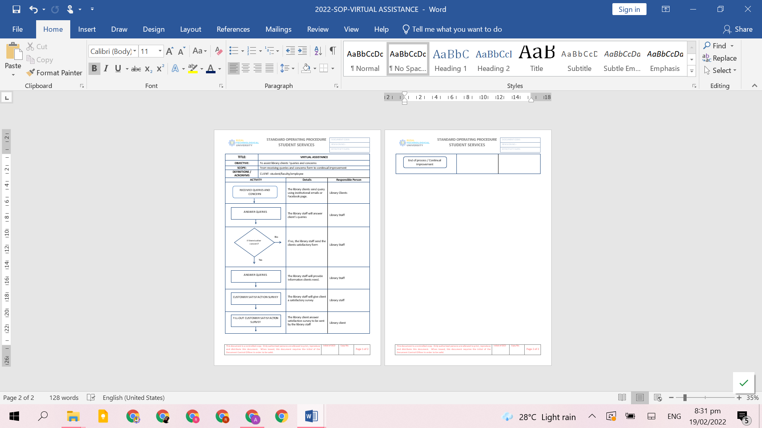

5

3.4.2 Online Document Delivery

6

3.4.3 Online Clearance

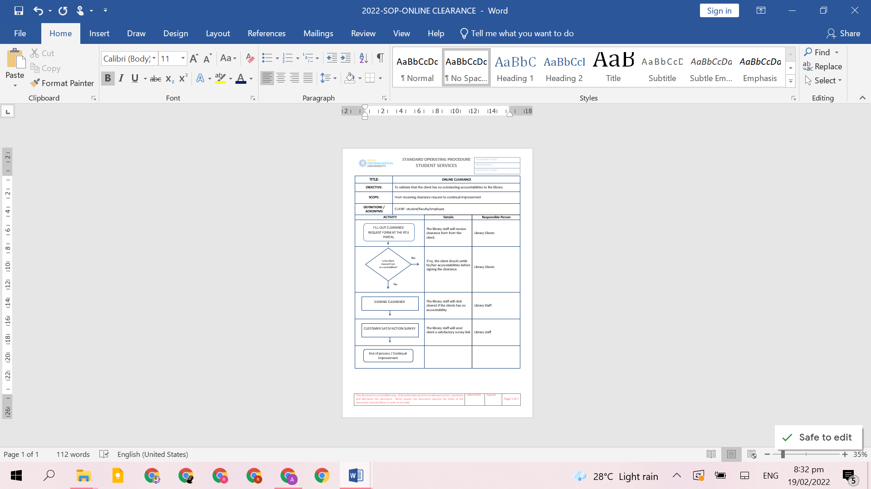

7

3.4.4 Borrowing and Returning of Books

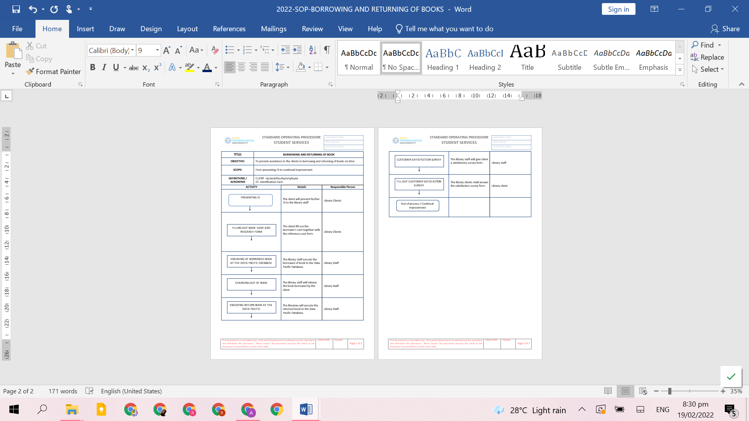

8

3.4.5 Internet Searching

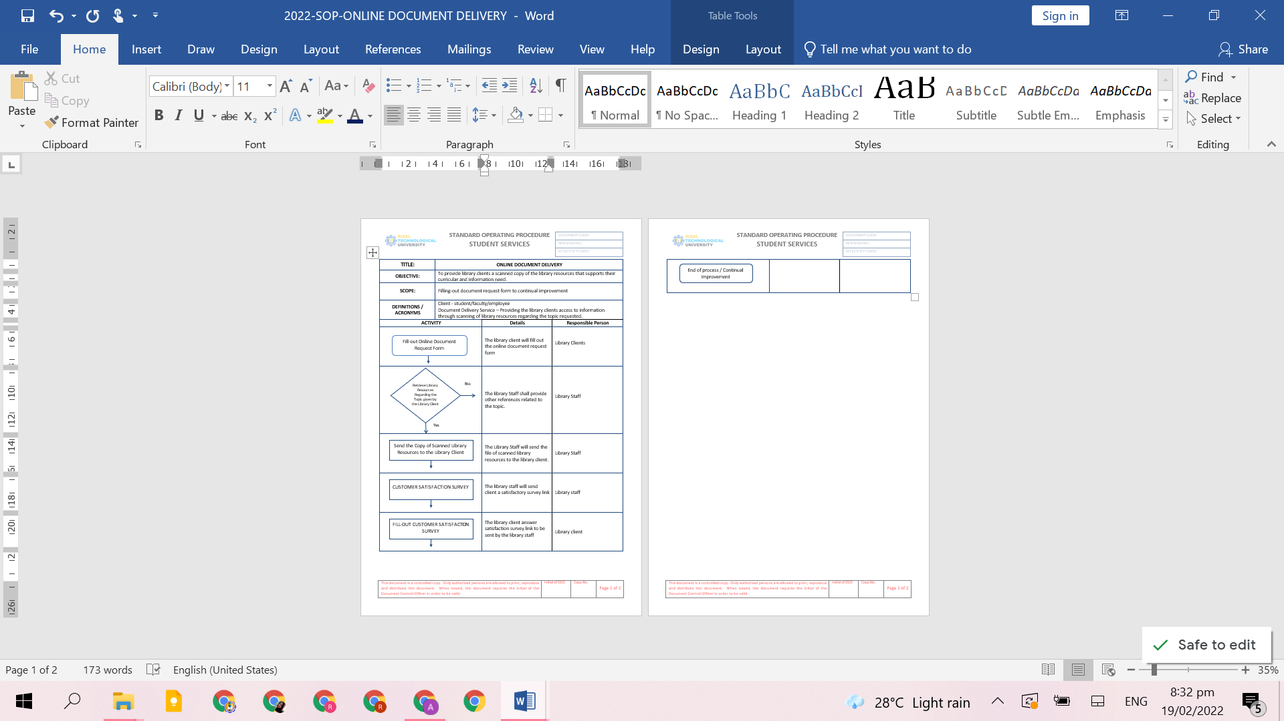

9

3.4.6 Received Publication

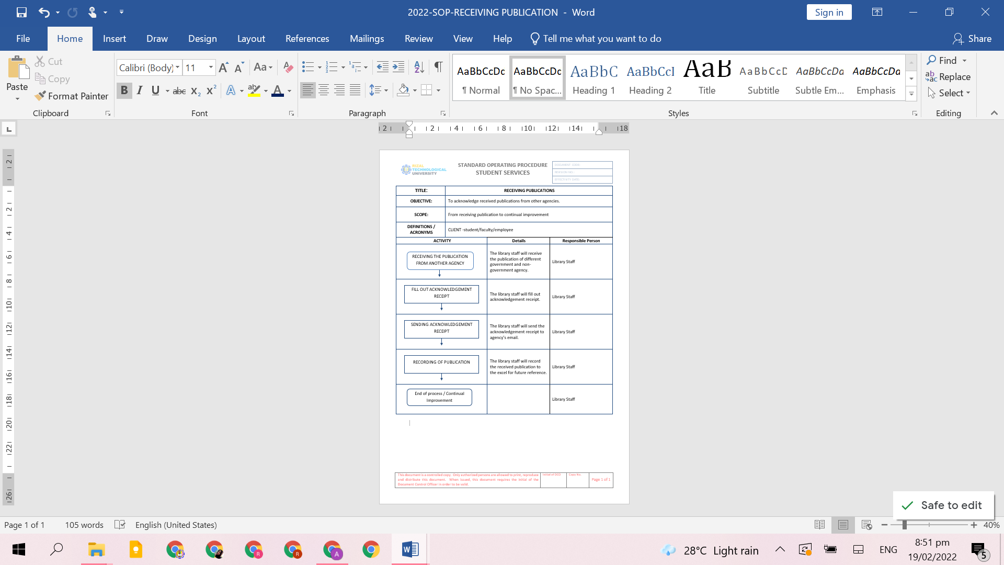

10

3.4.7 Referral Letter

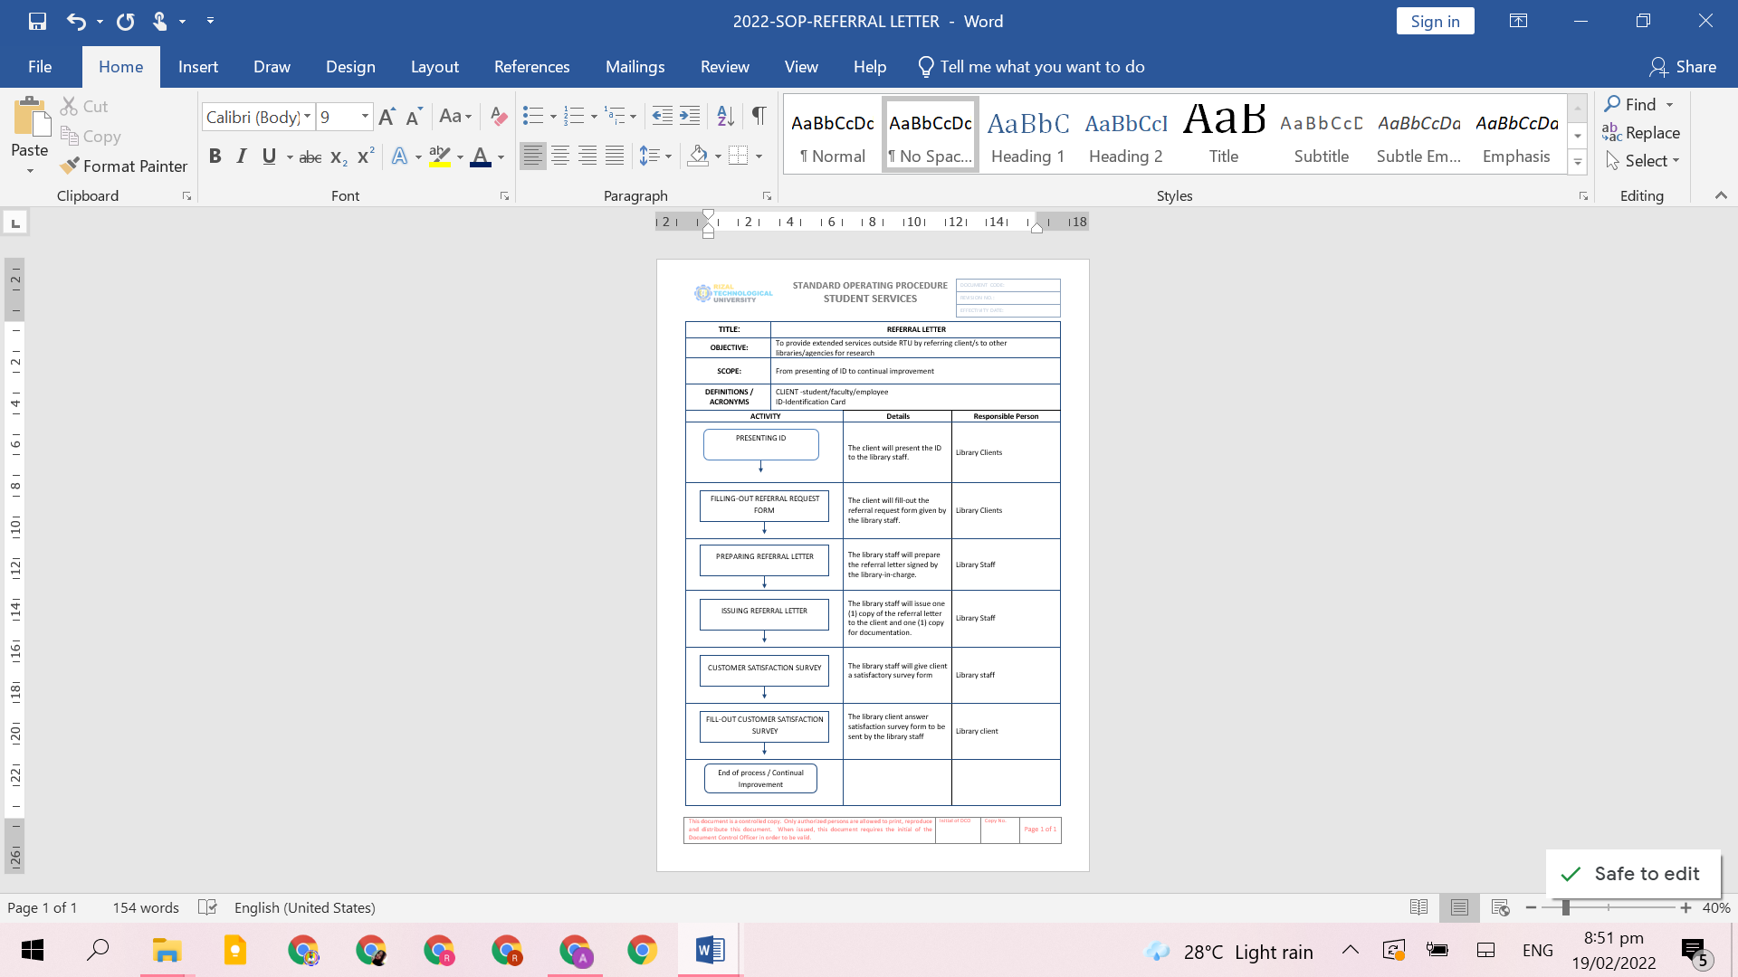

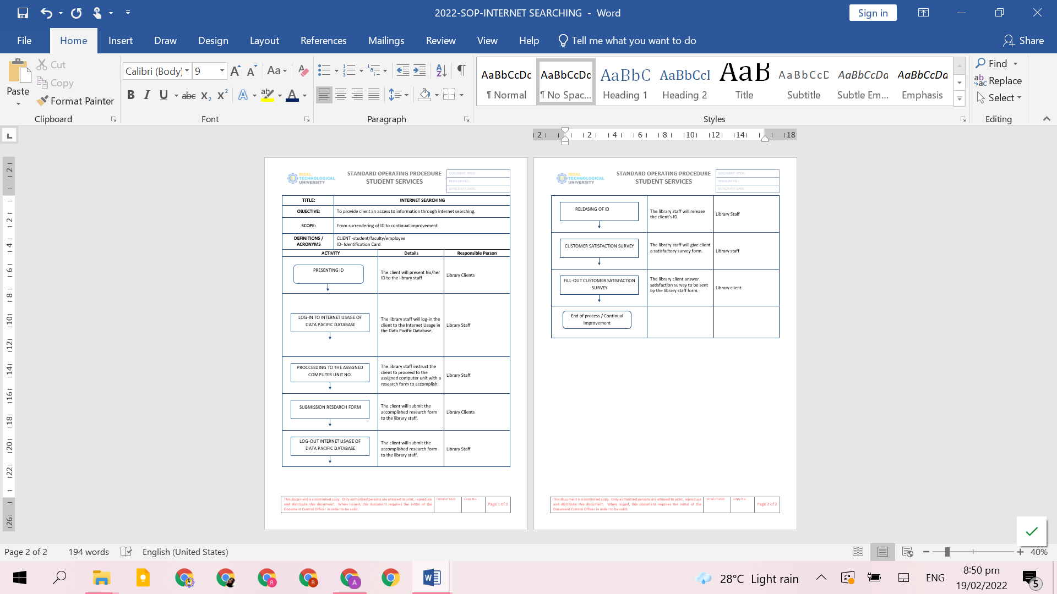

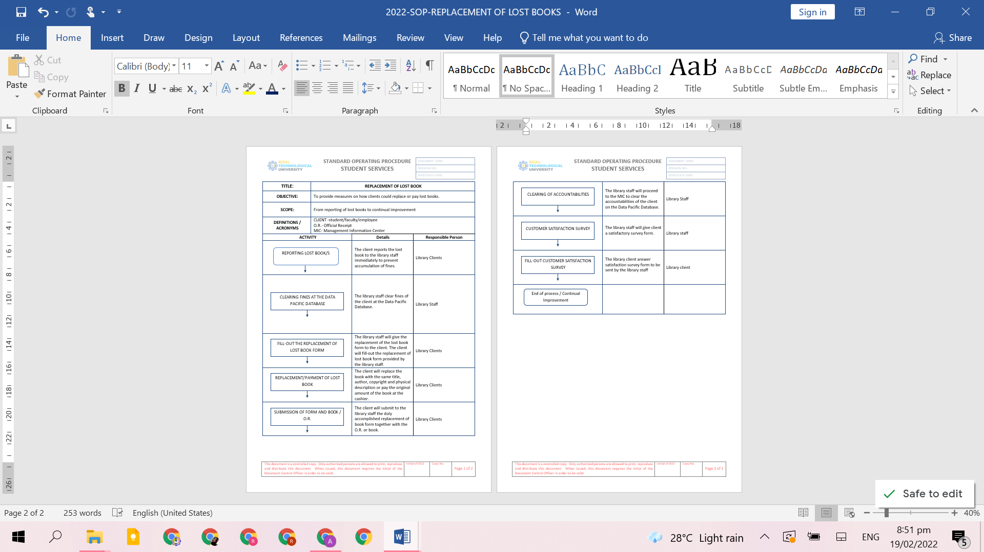3.4.8 Replacement of Lost Books

11

12

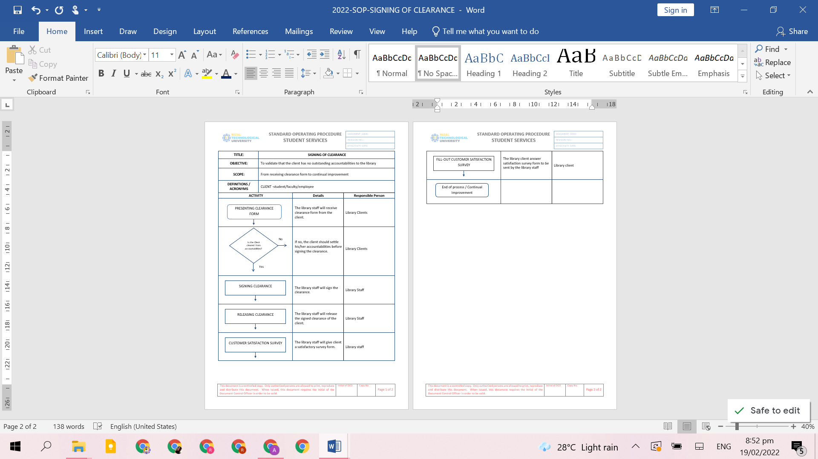3.4.9 Signing of Clearance

13

**3.5. CITIZEN’S CHARTER**

3.5.1 Borrowing and Returning of Books (Face-to-Face)

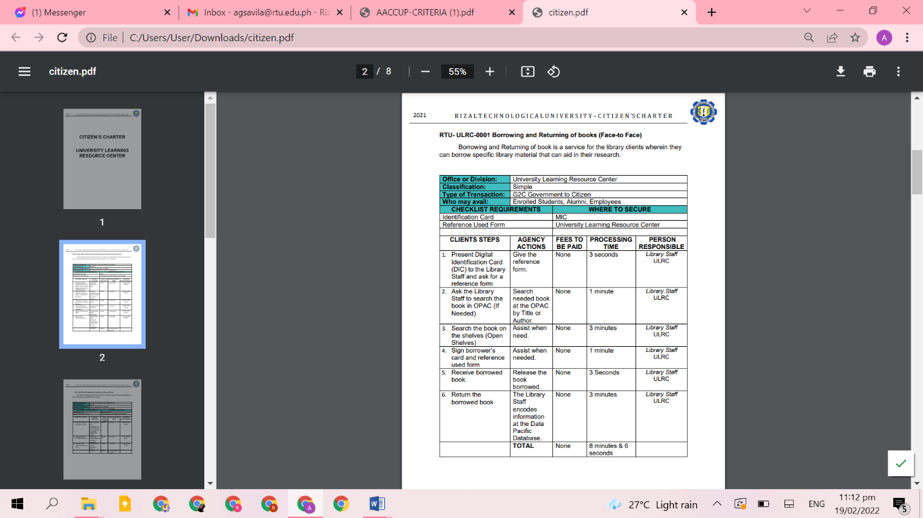

14

3.5.2 Signing of Clearance (Face-to-Face)

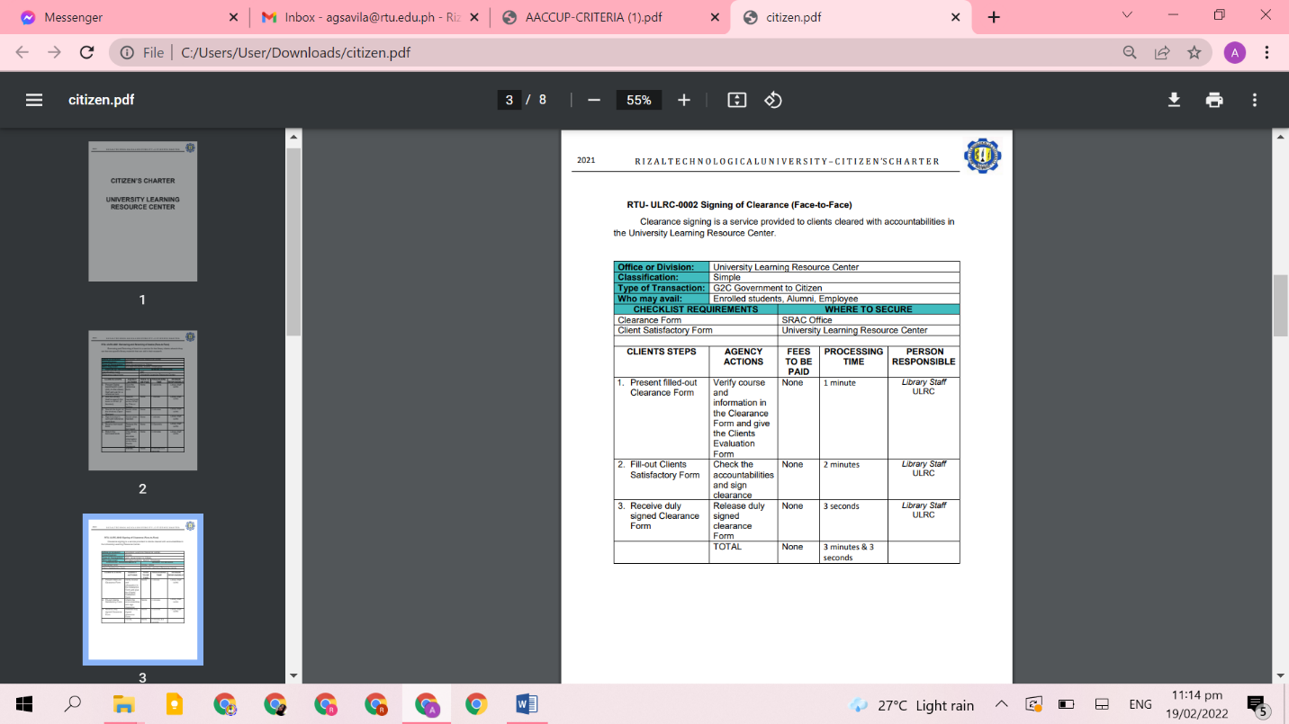

15

3.5.3 Signing of Clearance (Online)

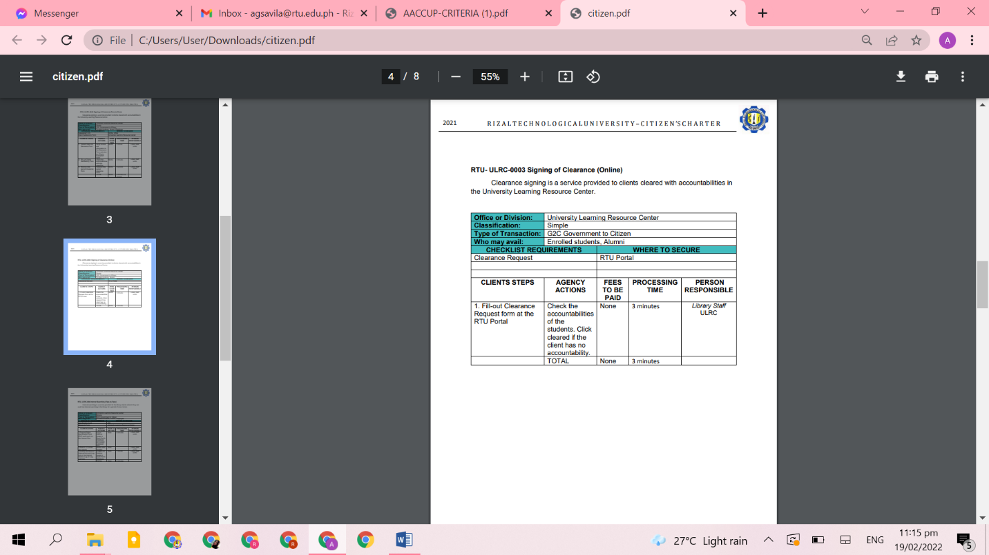

16

3.5.4 Internet Searching (Face-to-Face)

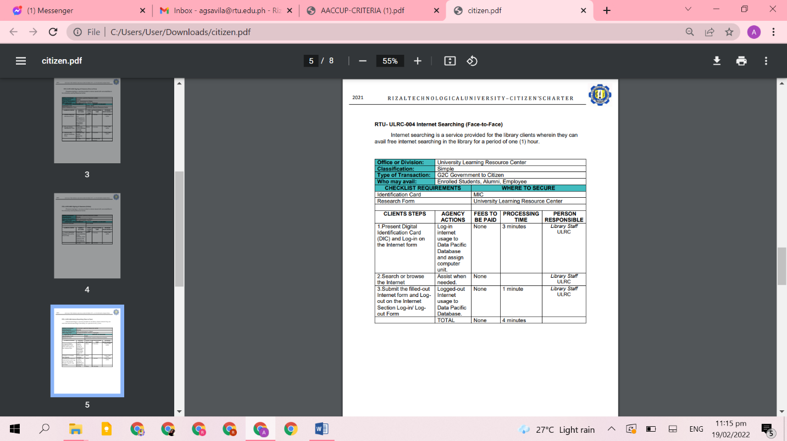

17

3.5.5 Referral Letter (Face-to-Face)

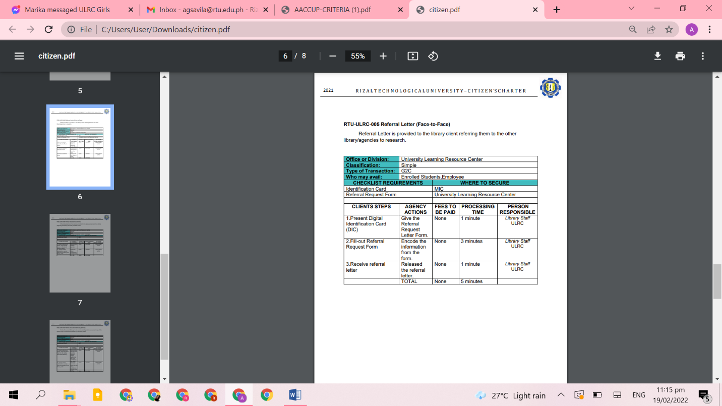

18

3.5.6 Virtual Assistance (Online)

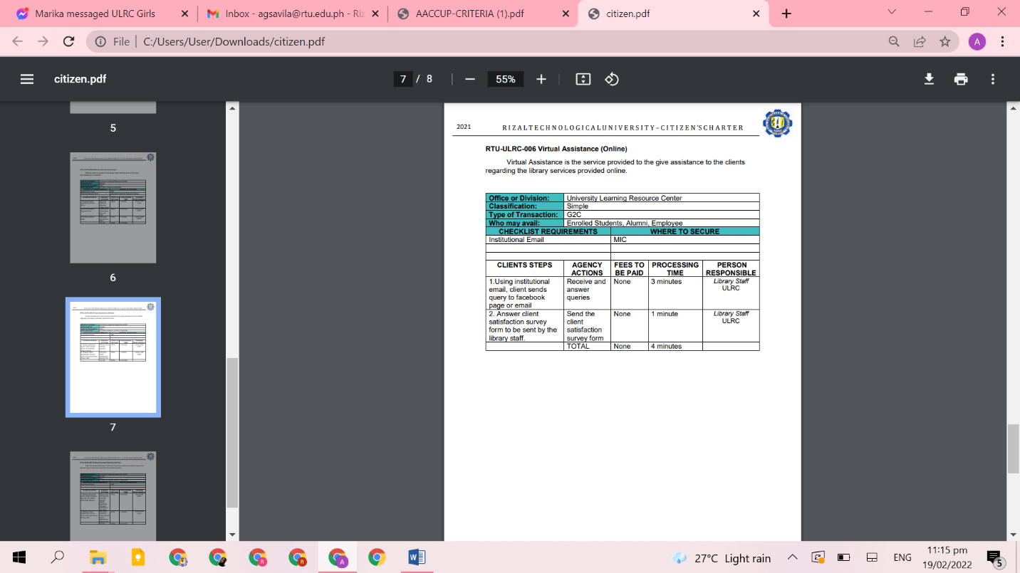

19

3.5.7 Online Document Delivery (Online)

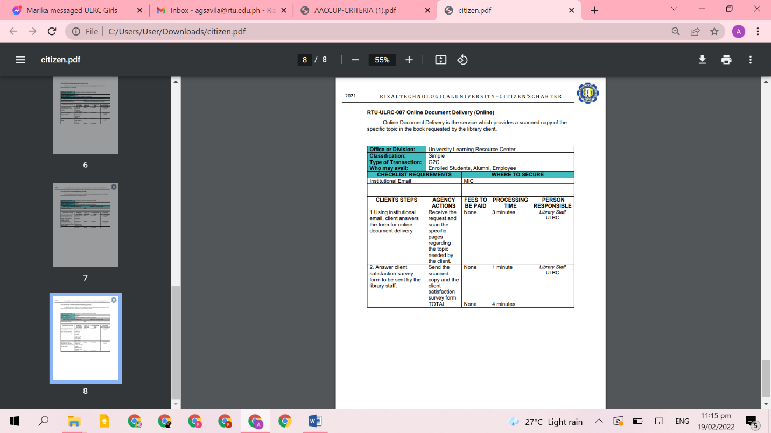

20

**3.6. QUALITY POLICY**

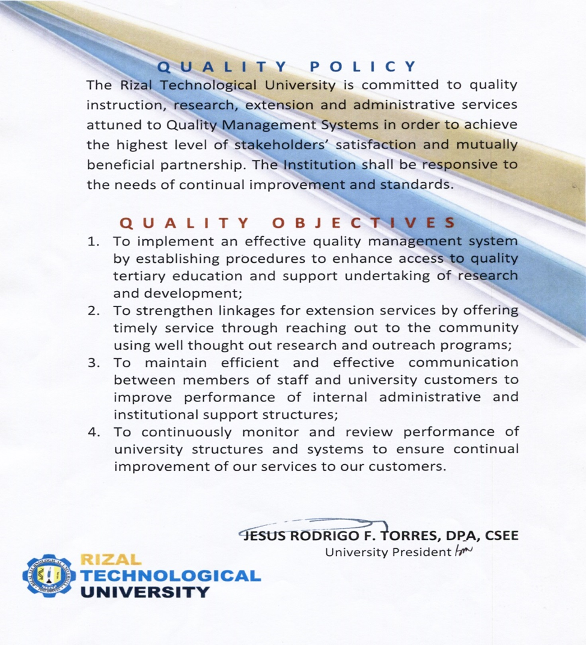

21

**4. LIBRARY SERVICES**

Below are the service areas of the libraries and reading centers. Other services or

sections shall be added if it shall be deemed necessary.

**1 Technical Services.** Responsible for the acquisition and classification of library materials. Upon acquisition, books and other library materials undergo different mechanical and technical processes. It should be made ready for circulation and use.

The Technical Services is divided into parts: processing, preparations, acquisition, cataloging, and abstracting.

**4.1.1. Collection Development Policy**

The University library is the springboard of success of the academe. The success in the academic performance of the students and the faculty are dovetailed to the library resources whether print or non-print materials and electronic resources. Information Technology affects the present condition of the libraries and information centers to be globally competitive.

In view of this situation, there is a need for analysis of the existing situation and problems affecting the University library in order to achieve its institutional objectives of quality education.

Building the library collection is not merely selecting and acquiring books and other library resources/materials. It requires full attention on the part of the library administrators and library users in order to achieve the goal of the library in providing the right and adequate information to the users. Furthermore, the library’s collection must be managed very well if the library aims to accomplish its objectives.

  The development of the library collection includes such elements as surveying clientele needs, budgeting, policy formulation, selection, acquisition, and weeding and collection analysis.

  Collection Development lies on the librarians and library staff. Ideally, everyone who uses the library should be involved in the development of the library collections.

  The library must offer a wide variety of well selected materials on a wide range of subjects in order to function efficiently. It is necessary to make use of the expertise of many people from various sectors of the community in order to effectively select and acquire library resources.

22

4.1.1 Objectives/Targets:

4.1.1. Strengthen collection program policies, guidelines and procedures in the acquisition of quality and recent books, and electronic materials through purchase, gifts, donations or exchange of publications;

4.1.2. Upgrade the collection and institute deselecting program for outdated books;

4.1.3. Organize print, non-print, and electronic sources of information for immediate use of patrons;

4.1.4. Improve library services by continuing education of the library staff to keep abreast of recent trends in libraries;

**4.2 Acquisition-** The process of acquiring library resources through purchase, gifts or deposits and exchange of publications or other library materials.

**4.2.1 Purchase**

**4.2.1.1 Selection-** Request the Library Advisory Board to select and recommend books and library resources for procurement either through pricelist of books or personal evaluation of books from the book stores or book fairs.

**4.2.1.1.1. Guidelines for Selecting Print Materials**

**4.2.1.1.1.1.a. Purpose, Scope and Audience**-The purpose is usually clear from the title, the table of contents, the Index or the jacket in which the publisher tries to summarize what the book is about. The scope can readily be ascertained from the contents and publisher’s description. The audience is a book written not for scholars and historians but rather for individual readers. The library audience may be young adults, people with reading problems, ethnic groups or others.

**4.2.1.1.1.1.b. Difficulty**- Popular, scholarly, and technicality are the three key words to keep in mind when evaluating the difficulty of a book for a particular audience. The obvious flaw in this is that one person’s popular book may appear technical or even scholarly to another.

**4.2.1.1.1.1.c**. **Authority-** honesty and credibility of author and publisher.

**4.2.1.1.1.1.d**. **Subject matter**- When books are advertised, listed and reviewed in subject areas, which are in demand, by the users, you double check the purpose, scope, and audience to see whether or not they fit.

**4.2.1.1.1.1.e. Comparison**– Comparison in scope, purpose and audience with other works in the library collection.

23

**4.2.1.1.1.1.f. Timeliness**- Some types of books, particularly the classics in both fiction and nonfiction are literally timeless. The library refuels to built titles that are more than five years old again, classics being an exception. The due can easily be checked on the title page or on the copyright page (the verso for the title page). Older titles are selected only when nothing comparable has been published recently. Justification for not purchasing an older book can be shown, when the subject is no longer of interest to the library audience. Most important in terms of timeliness is the new edition.

**4.2.1.1.1.1.g. Format**– The type of material must be legible, the covers likely to withstand repeated use, the photographs current. The format requirement is applicable to a novel as well as to non-fiction, particularly in terms of binding and typography.

**4.2.1.1.1.1.h.** **Price**- Cost should not be a factor in itself, but it is a major consideration when the price of a book or any other library material is far beyond the average.

**4.2.1.1.1.1.i. Curriculum Support**- The books and other instructional materials should be in support of the anticipated or possible future programs of the institution.

**4.2.1.1.1.1.j.** **Demand**– If there is a request for a book in most cases the title may be considered to be purchased

**4.3.1.1.1. Guidelines for Selecting Non-Print and Electronic Materials–** Includes audio and videocassettes, filmstrips, slides, transparencies, computer software, disc, etc. The following are the guidelines in selecting print materials

a. **Cost-** of the media considering initial purchase, replacement needs, and growth in the collection.

**b.Type-** The kind, and cost (including maintenance) and quality of the equipment required using the media.

**c. Compatibility** with existing collection and media hardware.

**d. Staff supervision or assistance** required for the use of the media

**4..1.1.2 Checking the budget** - Determine the funds available for the purchase of the library materials eliminates encumbrances or overdrawn of funds.

**4.1.1.3 Ordering-** Prepare the Terms of Reference for the Procurement Program and attach Project Procurement Management Plan submit to Financial Service Center for approval.

**4.1.1.4 Pre-Bidding-** The BAC will notify the end-user to attend the Pre-Bidding Meeting.

24

**4.1.1.5 Bidding-** The end-user will attend the bidding conference.

**4.1.1.6 Receiving-** Check the accuracy of the materials if these are the exact orders against the delivery receipts.

**4.1.1.7. Inspecting** –Determine whether it is complete or there is imperfection in the materials such as inverted printing, no print, lack pages.

Return to the book supplier/s for replacement of books or books not included in the purchase order.

**4.3.1 Gifts-** Gifts are an augment to library collection as long as they are given with “no strings attached”. The library accepts gifts provided it suit to the collection development policy and there are no restrictions attached to their disposition and location. The monetary appraisal of gifts is not the responsibility of the Library.

**4.3.1.1. Guidelines in Accepting Gifts**

**a.** The value of gift should be against space limitations and the cost of processing materials.

**b.** The library has the right to dispose of any gift materials at the discretion of the librarians.

**c.** Potential donors shall be requested to provide in advance a list of materials being offered so that their value to the collection may be assessed.

**d.** Only those materials which prove to be in good condition and which conform to the collection’s goals, guidelines, and policies are actually added to the collection

**e.** Gift items will be acknowledged and the credit is listed in the library records. Publicity is given to donors of outstanding gifts to encourage others to follow the same generosity

**f.** There should be no onerous condition from the donor on what to do with donated materials

**g.** The Library shall only accept books of current publications in social sciences, engineering and technology, classic books in literature, and history, religion, pure sciences and philosophy because of its timelessness.

h. Everything donated to the library becomes its property based upon the collection needs and policy.

25

**4.4.1. Exchange of Materials–** Exchange publications with other institutions which are difficult to obtain, purchase or unavailable by any other means like foreign government documents, research journals, periodicals, and others shall be accepted.

**3.1.2 Cataloging**

The Cataloging is organizing the library sources of information through cataloging and classification. Cataloging and classification are highly specialized activities, which require definite training on the part of the person who performs them.

The purpose of cataloging is to put order into collection of books so that the volumes may be located and used for reference and circulation. The purpose of classification is to facilitate the discovery of knowledge in literature by grouping together the books according to the Dewey Decimal Classification System. In the Dewey Decimal System, all knowledge is divided into ten main classes numbered 001 to 999, and each class is divided into ten divisions and again into ten subdivisions.

**3.1.2.1 Tools Use for Cataloging**

**3.1.2.1.**1. **Anglo – American Cataloging Rules. 2nd ed**.- These are rules designed for use in the construction of catalogues and other lists in general libraries of all sizes. They are not specifically intended for specialist and archival libraries, but such libraries are recommended to use the rules as basis of their cataloging and to augment their provisions as necessary. The rules cover the description of and the provision of access points for all library materials commonly collected at the present time.

**3.1.2.1 2. Sears List of Subject Headings by Minnie. E. Sears**

It is a printed list of subject headings for the minds representing various types of libraries. By using the list as a base for establishing subject headings, the cataloger has a standard on which to rely. Consistency on both level of specificity and accepted list where the choice among possible wordings has been made and received is on the list. By following the patterns of headings printed in the list, the cataloger will also have to add new headings that will be compatible with the tool.

**3.1.2.1 3. The Dewey Decimal Classification System**

It is a classification system, which divides human knowledge into ten main classes with further decimal division using a notation of numbers. It is called decimal system because knowledge is divided and subdivided in group of tens.

**3.1.2.1 4. C.A. Cutter’s three-figure author table**

Author numbers are usually taken from this table in which numerals are assigned to letters of the alphabet in the order of the alphabet thus, providing for the alphabetical arrangement by the author.

26

**3.1.2.2 Objectives of the Cataloging**

**a.** To organize library materials for effective use by the library customers through:

a1. Cataloging – which is describing each title in bibliographic terms, according to cataloging rules (i.e. Anglo-American Cataloging Rules, 2nd ed., 2002 revision)

a2 Subject analysis – which is identifying the contents of each title and representing these by appropriate subject headings.

a3 Classification – which means applying to each title a symbol representing its place in a classification scheme designed to arranged books systematically on the library shelves; and

a4 Proper distribution of processed materials to their respective units/sections.

**b.** To improve bibliographic control over materials by participating in the production and maintenance of permanent bibliographic records for public and staff use in the form of Card Catalog (composed of the Author, Title and Subject card catalogs), the Shelf-list and the New Acquisitions List.

**c.** Facilitate easy access to the bibliographic information of the library collection through the maintenance and updating of the Online Public Access Catalog (OPAC) records thru automated catalog database.

**3.1.2.3 Cataloging Process and Policies–** The Library shall perform the cataloging process to assist library users and staff in the determination and the location of available information resources in answer to their specific needs.

**3.1.2.3.1 Descriptive Cataloging.** In descriptive cataloguing, the following shall be observed:

a. The tools that shall be used shall be the International Standard Bibliographic Description (ISBD) and the Anglo-American Cataloging Rules 2nd edition (AARCR2).

b. The third level of bibliographic description shall be used to describe the bibliographic record.

c. The areas of description shall include: title and statement of responsibility, edition, material type, physical description, series, notes, and standard number

27

d. The access points to be considered shall be the: personal author, corporate body, and uniform title.

d.1 Personal Author. This shall refer to the person chiefly responsible for the creation of the intellectual or artistic contents of a work (e.g., writers of books and composers of music shall be the authors of the works they create; compilers of bibliographies shall be the authors of these bibliographies; cartographers shall be the authors of their maps; and artists and photographers shall be the authors of the works they create; and performers shall be the authors of sound recordings, films, and video recordings). For example: Whitten, Jeffrey L.

d.2 Corporate Body. This shall refer to the organization or a group of persons that shall be identified by a particular name and acts, or shall act as an entity (e.g., associations, institutions, business firms, non-profit enterprises, governments, government agencies, projects and programs, religious bodies, local churches, and conference). For example: Asian Development Bank.

d.3 Uniform Title. This shall refer to the title which shall bring together entries for different publications of the same work, when those publications shall have different titles proper.

**3.1.2.3.1.1 Steps of Descriptive Cataloging**

Descriptive cataloging shall involve the following steps:

a. Provide bibliographic description on a 3 x 5-inch process slip using the ISBD and the AACR2 as bases of format content;

b. Search author and title entry in the OPAC; and

c. Proceed to subject cataloging and classification.

**3.1.2.3.2 Subject Cataloging and Classification**– determine the appropriate subject of the library material using the different subject tools.

**3.1.2.3.2.1 Steps of Subject Cataloging and Classification-** Subject cataloging, and classification shall involve the following steps:

a. Using the Sears List of Subject Headings by Minnie. E. Sears, the cataloger shall provide appropriate subjects for material being cataloged.

b. The cataloger shall provide added entries, if there shall be any, to complete the tracings.

c. If appropriate subject shall not be available in the Sears List of Subject Headings by Minnie. E. Sears, the cataloger shall consult a specialized thesaurus appropriate to the material being catalogued, or, refer to the OPAC of the Library of Congress and the Philippine e-Library.

28

d. The cataloger shall assign corresponding call number to the cataloged material.

**3.1.2.3.3 Mechanical Preparation of Cataloged Library Materials.** The following steps shall be done in the mechanical preparation of cataloged library materials:

a. Encode and print call numbers on appropriate paper.

b. Cut and paste call number on the spine of the cataloged book, 1 inch from the bottom. For spiral and thin materials, provide call numbers on the left side of the front cover.

c. Provide book accessories, i.e., book pocket, book card, and date due slip.

d. Cover material with plastic for preservation.

e. Shelve cataloged materials at the new acquisitions display area.

**3.1.2.3.4** **Card Reproduction**. In reproducing cards, the following are the steps.

a. Encode main or author entry/card:

a.1 Encode the call number two spaces from the top and two spaces from the left side of card.

a.2 Encode the author’s name at the first indention on the third line from the top of the card alongside the class number. Type last name first, followed by the comma, one space, then first, and middle names or initials. If main entry is corporate entry, type corporate name as written in the book. If entry runs over one line, drop to line beginning at the third indention

a.3 Encode the title starting on the second indention just below the author’s name. If title transcription runs over, next line and every line thereafter starts on the first indention.

a.4 Encode the imprint (place of publication, publisher and date of publication or copyright date) after the title transcription, a full stop, a space, dash, and a space in the same transcription paragraph. If copyright is used, type a lower case letter c before the date.

a.5 Encode collation (i.e., physical description of the book, such as extent of item, other physical details, dimensions, and accompanying material, if there is any) next line below the title transcription paragraph starting on the second indention.

a.6 Encode in the series area each series statement before a full stop, a space, area, such title proper of series, series author, series number, and subseries).

a.7 Encode the standard number

a.8 Encode the tracings (indications of added entry card) at the bottom of the card just above the hole, starting transcription paragraph on the second indention.

29

a.9 Encode cards for unit libraries

b. Encode subject entries/cards:

b.1 Encode in all capital letters on the second line indention. If the subject runs over, type on the next line starting on the third indention.

b.2 Proceed to steps a.1 to a.7 of Encode main or author entry/card.

c. Encode added entries/cards:

c.1 Encode the co-author/title entry on the second line starting on the second indention. Capitalize only the first letter of the first word/name (articles excluded) and first letters of proper nouns.

c.2 Proceed to steps a.1 to a.7 of Encode main or author card.

d. Encode the shelf-list entry/card:

d.1 Follow steps a.1 to a.8 of Encode main or author entry/card.

d.2 Encode the additional accession number/s and corresponding location/s of the book

**3.1.2.2.5 Sorting of Cards.** The following steps shall be observed in filing of cards:

a. Sort catalog into author/author added entry cards, title added title entry cards, subject cards, and shelf-list cards.

b. If a card catalog already exists, interfile alphabetized sorted cards into their proper order from the top of the card starting on the second

c. If a card catalog does not exist yet, alphabetize the sorted cards using the ALA rules for filing, then file the alphabetized cards in their proper order.

**3.1.2.4 Cataloging and Classifying Non-print Materials**

The assignment of subject to materials follows the same principles with that of books. The headings most specifically describing the contents of the materials are used and the same headings are applied to book and non-book materials and the like. This is especially important if the catalog integrates all media. One integrated catalog would seem to be preferable because this would bring all materials on one subject together regardless of format.

Non-book materials often concentrate on very small aspects of larger subjects. Hence, the catalogs may not find in the list of subject headings that should be used. In such instances, the cataloger should add new subjects. It is also necessary to use a form heading for the format of the materials as well as a subject heading for the content. Biography films for examples could be created a subject if needed to describe a type of film.

30

Subject heading for non-book materials should not include form subdivisions to describe physical format. i.e. motion pictures, slides, sound recording, music, etc. AACR2.5 provides the option of using general material designations (GMD), which are placed, at the end of the title proper and alert user to the general class to which an item belongs. The appropriate TMD is selected from either the North American List of the British List. Additional information, on this aspect of descriptive cataloging can be found in the Anglo-American Cataloging Rules. 2nd edition, 1988 revision.

**3.1.2.4.1 Classification of Non-Print Materials**

a. Chart – a sheet or information arranged in tabular or diagrammatic order

b. Diorama – a scene reproduced in three dimensions by the placement of objects, figures, etc. in front of a representational background.

c. Disc – a recording on a flat, circular, piece of material

d. Filmstrip – a roll of film containing a succession of images designed to be viewed one at a time, with or without sound track.

e. Game - a set of materials designed for recreation of instruction.

f. Globe – sphere with a representation or a map of the earth (terrestrial globe) or of the sky (celestial globe)

g. Kit – a combination of more than two media designed to be used as a unit.

h. Laboratory Kit – boxed coordinated materials designed to promote specific learning experiences.

i. Magazine – is a sort cover collection of printed materials. Often illustrated, issued at a regular intervals.

j. Map – flat representation of part or all of either the earth, or the universe.

k. Microfiche – a micro reproduction on a roll of film.

l. Model – a three dimensional representation of an object either exact in size or constructed to scale.

m. Motion Picture – film with or without sound track, bearing a sequence of images that create the illusion of movement when projected.

n. Motion Picture Loaf – a length of film whose ends are spliced together to form a loaf that may be projected continuously.

o. Newspaper – printed material current issued regularly.

31

p. Pamphlet - a sort-cover booklet often one of a series issued regularly or irregularly.

q. Picture – a two-dimensional drawing, painting, portrait or photographs, or a print of these, produced on an opaque backing.

r. Realia – actual objects or specimens.

s. Relief Model – a three-dimensional map other than a globe.

t. Slide – a small unit of transparent material containing an image, mounted in rigid format and designed for use in a slide viewer or projector.

u. Sound Recording – a recording, sound, disc or tapes.

v. Study print – a picture with accompanying text that makes the print significant for study purposes.

w. Tape – a recording of sound (audio tape) or of sound and pictures (videotape) produced on magnetic tape/ (a ribbon of plastic, coated with magnetic particles): contained in cartridges or cassette or held on open reels.

xTransparency – an image production transparent materials, designed for use with an overhead projector.

y. Video recording – a recording of pictures, tapes or disc: usually with accompanying sound designed for playbacks on a television set.

z. Art print - a printed production of a work of art, e.g. painting, drawing, sculpture.

**3.1.3 Abstracting and Indexing**

Abstracting is the act of abstracting the information to facilitate research. A good abstract should also have the following qualities:

a. A self-contained unit, a complete report in a miniature forms; it should be intelligible without reference to the original document.

b. Enable its users to identify the basic contents of a work quickly and accurately, determine its relevance to their interest and decide whether or not to read the original document in its entirely.

c. Capable of being used as a secondary source of information.

d. Impersonal

e. Do not take a critical form

f. Up to date as possible

g. Able to be used as a retrieval aid in an automated information retrieval environment.

32

h. Do not repeat the information that is obvious from the title or is well known to the user.

i. Avoid redundancy and repetition.

j. Written in a clear and natural language and should avoid using abbreviations.

**3.1.3.1 Procedure in Abstracting and Indexing**

a. Develop the bibliographic reference, assign the DIN

b. Read the document

c. Note down key information

d. Organize the key information

e. Follow the standard abstract format

f. Check the draft

g. Edit and polish the draft

h. Write the final abstract

**3.1.3.2 Parts of the Abstract**

Three major parts of abstract: The reference, the body, and signature.

**3.1.3.2.1 The Reference**

The reference portion directs readers to the original document. The reference must be complete and accurate.. Placing the reference at the head of the abstract provides users with important clues that help them to decide whether or not to read further. The reference section of the abstract consists of many parts. All parts should be included if they help the reader to ascertain the relevance of the document and if desired, to locate and obtain the original documents. The following are the significant part of the reference:

a. Document Identification Number: The identification number is an accession number. The number points to the particular abstract and document

b. Author(s)-Provides means of identifying the article.

This caters to the preferences that certain readers may have developed and

provides means in listing of author names in the abstract.

Single Authors : Full or Abbreviated Name: The preferred rule is to print the name of the authors as found in the original document rather than to use the family name and initials.

Multiple Authors : All Author Names can be given or only limited number can be listed. Some abstracting services give all names, other services use the name of the first author and the substitution of et. al for the names of others. The abstract must be listed in the same order as in the original document.

33

Non-English Name : It these special characters are unavailable ones. For an anonymous work the term Anon can be used. Titles such as Doctor, Professor are omitted. The abbreviations Mrs. Mme, and Ms. are used if the husbands name is used in the reference.

Author Affiliation

The expressed affiliation of the author helps the reader to identify and evaluate the author, and it also gives the place where the document originated.

c. Sponsoring Agency and Agency Report Number

The sponsoring agency assigns its own number to the report.

d. Contract or Grant Number

The contract number or the grant number enables one to locate the original document

e. Source and Date of Publication

The purpose of the source and date of publication is to enable the reader to locate the original document. After the journal name, some services place numbers important in locating the work. The series number, if there is one may be placed in brackets after the journal name. After the series number comes a coma and then the volume. The issue number may follow a colon after the volume number. Ex. Child Psychology 14:3, 40-3 (1998)

f. Original Language/Source of Translation- If the article is being prepared in a foreign language, this should be stated. Indicating the language of the original article may save the reader from turning to an original.

g. Descriptive Note– The role simply provides the reader with additional information about original document.

h. Alternative Source for Obtaining the Document

Identical material maybe published in more than one place. When the report appears later as an article in a journal, brief abstract and a cross-reference may be used.

i. Price- The boldface print also serves a secondary function, which divided the reference portion from the body of the abstract.

**3.1.3.2.2 The Body-** contains the subject matter derived from original word wherein it is divided into two parts : the descriptors and the abstract proper.

a. Descriptor : Refers to general subject heading. It is now used interchangeably with subject headings and keyword. Provides the reader with additional guidance to the subjects discussed in the document. Provides the reader with a list of terms useful for filing the abstract in a personal retrieval system. Provides the reader with a list of terms use in a search for related documents. A computer can identify a block of descriptors at the start or end of the body of an abstract.

34

b. The Abstract Proper- The outstanding feature of the abstract is that it is smaller than the original article. It contains few words.Selection Content. Abstract omit history, introductions, information, redundancy, summaries and details of procedures.

Arrangement of Content. The body of the abstract can be arranged to save the readers’ time. Conclusions placed first may satisfy the reader and save further reading. Labeling each part of an abstract such as conclusions, results or procedures has been found to be unnecessary.

**3.1.3.2.3 Signature Section**

The signature identifies the abstractor or gives him credit.

Regardless of whether initials or full names are used, the journals should always publish a list-name of abstractors. ((Lancaster, 1998))

**3.1.3.3 Indexing-** Indexing is a process of identifying and assigning index terms to a document, either to describe its physical characteristics, give facts about its creation or distribution or describe its contents.

**3.1.3.3.1 Purpose of Indexing**

To construct representations of documents in a form that is suitable for the users to browse through in machine-readable form, microform, printed form and card form.

a. Facilitate reference to the specific item or to locate wanted information

b. Disclose relationships

c. Make the information storage & retrieval system useful to individuals

d. Serve as filter to withhold irrelevant material

e. Provide a comprehensive review of a subject

f. Give nomenclature guidance

**3.1.3.3.2 Principles of Indexing**

The principles of indexing are exhaustively, specificity and consistency.

35

**3..1.3.3.3. Types of Indexes**

The types of indexes are author, alphabetical subject indexes and classified indexes.

a. Author Indexes. Entry points are names of persons, organizations, government agencies, institutions, etc.

b. Alphabetical Subject Indexes. Entry points are subject terms, personal, corporate and place names arranged in an alphabetical order. Examples of these are Readers Guide to Periodical Literature, Education Index, Library Literature and Information Science, etc.

c. Classified Indexes. Entry points are arranged in a hierarchy of related topics starting with generic or broad topics and working down to the specific ones. Examples of these are the Engineering Index and the Index Medicus.

**3.1.4 Preservation and Conservation of Library Materials**

The primary objective of preservation of the library collection is to guarantee that the collections last in good condition for as long as they are needed. Preservation should never be limited to the treatment of a few select items. The most cost-effective way to establish longevity is to prevent deterioration.

**3.1.4.1 Care of the Books Collections**

Requirements for the proper care of the collection:

a. Adequate space for the storage of books, with proper control of temperature and humidity.

b. Space at the end of the shelves to allow for expansion without a constant shifting of volumes.

c. Liberal use of supporters to hold books in place.

d. Special shelving for quarto and folio books which require careful handling.

e. Provision for housing rare and finely ported materials. **3.1.4.2 Physical Upkeep of Material**

a. Making final decision on items to be bounded, mended or discarded- The duty is professional to the extent that decision requires knowledge of the value of books from the standpoint of demand, content and rarity. It also requires judgment as to relative cost and feasibility of binding and mending, the extent of usefulness, both present and potential, of the items in question and the possibility of replacement.

36

b. Negotiating with binding agent-Negotiations concern such matters as price, standards of materials and workmanship and the length of time the material must be inaccessible. The negotiations may be merely verbal or they may involve detailed contracts.

c. Supervising upkeep processes This duty includes checking on the quality of work done for the library by commercial or other binderies and on the efficiency of the mending and preservation methods within the library. Occasional conferences on the physical condition of the library collection will stimulate suggestions for improvements in methods and procedures.

d. Preliminary sorting This duty includes the sorting of books that are in poor condition, into large groups consisting of those which are completely worn out, those which must be rebound if they are to be retained in the collection and those which can be mended if it is decided they are worth the time. The final sorting has been described under the professional duties section

e**.** Cleaning and treating for prevention Books in constant use require frequent cleaning of both covers and pages. This is done by washing, erasing and using various commercial cleaners. Special skill and knowledge of materials and methods are necessary where rare books are concerned. Certain bindings such as leather, sheepskin, and vellum require special treatment at intervals to prevent drying and cracking.

f. Repairing- This duty involves a careful examination of the book or other item to be repaired, deciding on the kind of treatment needed and selecting materials best suited to do the work. The rest is a matter of neat and careful handwork and skill in the use of book repair tools and equipment. Repairing include such processes as mending torn leaves, inserting loose leaves, sewing in loose signatures, re-casing books which have broken away from their covers, putting on new backs and covers, reinforcing fragile maps and plates. Repairing rare items involve special care.

g. Duplicating missing pages- When the book has one or two missing pages but it otherwise repairable, the missing text is sometimes typed from a duplicate copy to be put in the proper place when the volume is repaired or rebound. The Library reproduces missing pages by a photocopying process.

h. Disinfecting books- This consists of disinfecting by one of several approved methods, books which have been in quarantined house or in possession of someone with an infectious disease. Most health authorities now agree that exposing the pages to sunlight is all that is necessary and many libraries no longer fumigate books.

i. Preparing materials for binding- The amount of detail involved in this work varies according to existing agreement with binding agents. In the case of newspapers, magazines or serials, the tasks include arranging and tying together the separate items that are to be bound in each volume and indicating exactly what is to be printed on the cover.

37

j. Keeping bindery records- Part of the bindery process consists of keeping a charge record of the titles and volumes of materials sent to the bindery, and discharging them when they are returned. Record showing the number of circulations before binding and between binding and discarding are often kept, as a guide in formulating policies in physical upkeep. A check of the materials against the binders’ invoice is made when shipments are returned.

k. Inspecting books returned from the bindery-This consists of examining the volume to see that they are complete and in the case of periodicals and other serials that the numbers are in proper sequence. The printing on the cover must be checked to be sure it is correct and the quality of materials and workmanship will also be examined.

**3.1.4.3 Care, Handling and Storage of Books**

a. Damage to a book is cumulative. The repeated incorrect handling and storage of a book can quickly transform a new book into a worm or even an unusable one. Proper and storage in stable, cool, clean, non-humid environment can prolong its life.

b. The environment around the book is a major concern because unacceptable levels of temperature and humidity will accelerate deterioration. For example, the high humility in an attic or basement can promote mold growth, cockle pages, attract insect. Extremely low humility, as found above hot radiators, can dry out leather building.

c. Direct sun-light, with a large ultraviolet (UV) component, will fade leather and cloth. Blue leather fades it dull green and red leather to brown, especially along the spine of the book.

d. Dust, dirt and grime from handing can adversely affect books as well. Many people shelve their books in closed glass cases away from brightly lit windows or damp exterior walls to minimize the amount of dust and grime that will accumulate.

e. How we handle and use book contributes to its longevity. If a book will not lie flat, do not use force to open future. The covers should always be supported when the book is open.

f. Many books are damaged by the habit of pulling the books off the shelf with the head cap or the top of the spine. It is a much better practice to push the two adjoining books inward and remove the book by grasping the spine.

g. Place similar sized books, next to other on the shelf vertically, packing them neither too loosely nor tightly. This will help to prevent warping of a tall book next to a short book.

38

h. The use of paper clip and marking pens to make notations should be discouraged since clip will rust or crimp the pages and pens often bleed through the pages, obscuring text.

i. The folding of page corner is also damaging as it will often cause the page corner to break off over time.

j. The practice of using rubber or string to tie-up a book should be avoided because both will cut into brittle pages and damage fragile corners. A flat, soft ribbon (such as cotton twill tape), can be used to tie up the books as an immediate and temporary solution. An excellent way to protect fragile books is with a box that is custom made to the dimension of the book. Books with dry flaking leather covers can be wrapped in adjoining books and the rest of the pages.

3.1.4.4 **Drying Procedures of Water Damaged Collections**  a. Safety Precautions. Wear protective, latex gloves and long sleeves. If mold is present, wear a respirator. Some mold species are toxic; if any health effects are observed, contact a doctor and / or mycologist. When cleaning items with dry mold, make sure the mold spores are drawn way from you i.e. by the use of a vacuum cleaner. Wash your hands after handling materials with mold

b. Air –drying. Use fans to provide maximum air circulation. But do not aim fans directly at the drying materials. Absorb excess moisture using a clean sponge, paper or bath towels, etc. Do not blot on hand-written ink of fragile surfaces. Do not use printed newsprint for blotting, ink can transfer.

c. Air-drying Paper Documents, Maps, Posters, etc. Paper is very fragile when wet and must be handled with care, provide adequate support. Blot excess water off the documents. Do not attempt to separate individual items while very wet. You may leave them in stacks on higher than ¼ “to dry. If pages cannot separate safely they can be interleaved using absorbent or separating materials, such as waxed paper. Change interleaving materials until item is dry. Clean, undusted window-screens stacks with bricks or wood blocks between them will provide a drying surface with maximum air circulation. If drying items on a hard surface, cover area with maximum air circulation. If drying items on a hard surface, cover area with absorbent materials and change when wet. When items are almost dry, place them between protective sheets such as unprinted newsprint and put a light weight on them to flatten.

39

d. Air-drying framed items. Place the frame glass-side and remove the backing materials. Carefully remove object and air-dry. If the object is stuck to the glass, do not remove, instead dry frame with object inside, glass side down on a flat surface.

e. Air-drying Books. Fan books open and stand on top or bottom edge; never stand hem on the front edge. Stand book on driest edge first to provide support. As the book dries turn it upside down to the opposite edge every few hours. Place a sheet of waxed paper larger than the pages between the front and back cover and adjacent page before standing on edges. Replace the interleaving as it becomes saturated. When the book is no longer wet, but 90 still cool to the touch, close and place on a solid surface with a slight weight to keep distortion to a minimum. Check frequently to ensure that no mold is growing.

f. Air-drying Photographic Materials. Some historical photographs are very sensitive to water damage and may not be recoverable. Most prints, negative and color sides can be air-dried. The emulsion (picture or image) side should be face up. Avoid touching the front surface of wet or damp photographic prints or negatives.

**3.1.4.5 Care of Shelves Files and Catalogs**- The usefulness of any library collection depends upon the ease and speed with which books and other library materials can be located when needed. To this end, books are shelved according to some predetermined classification and in relative location to others within the collection. Problems incident to shelving and filing oversize books, documents, maps, posters, and other non-book materials such as films, music, etc, require special care.

a. Planning Shelving Arrangements. In planning shelving arrangements the librarian takes into consideration such matters as the kind of readers, frequency with which materials are called for; kind and type of materials to be shelved in relation to available space, kind of shelf labels and directional guide to be used and the location of them.

b. Shelving Procedure. This activity is concerned with when and how books are returned to their correct location after use. c. Shelving and Filing. Books, pamphlets and other library materials must be sorted and returned to their proper location after use. Methods of doing the jobs vary greatly, but arrangements in the shelves follows the library’s classification shame except for such materials oversize books, maps, records, magazines, picture, which by their nature require special housing locations of such collection are usually indicated by a distinguishing mark or label.

40

d. Keeping shelves and Files orderly. This task includes aligning books so that shelves are “dressed”, providing supports to keep books upright and stacking and typing unbound magazines and documents etc. to the end that stacks area are orderly in appearance.

  e. Physical upkeep of catalogs. Since a card catalog is a perpetual index continually added to and in constant use, its physical condition must be watched. When drawers become too crowded for easy consultation, cards must be shifted and space adjusted. This requires revising labels on drawer and after inserting additional guide.

f. Physical maintenance of catalog. In order to maintain the good appearance of a card catalog it will frequently be necessary to replace soiled or worn cards and to make new guide and drawer labels.

**3.1.5 Inventory-** A complete physical inventory is conducted every five years or when needed. The person who makes the inventory for each area has to read the shelf-list card and takes the book from the shelves and examines them. The date of the inventory is reflected in the shelf-list card. The book is marked with sticker that this has been inventoried.

Inventory is conducted to ascertain whether materials are on hand to check their physical condition. Set aside those need binding, rebinding and weeding out from the shelves for transfer to stack room or for condemning.

Through inventory the librarian can evaluate if the book is frequently borrowed and need additional copies if there is one copy only.

**3.1.6 Weeding or deselecting-**is the systematic removal of non-core volumes from the primary collection of the Library. It is a process, which is an integral part of collection development and maintenance. The librarians are responsible for weeding the collection in their areas on a continuing basis**.**

**3.1.6.1 Weeding or deselecting Criteria**

**a. Obsolete materials**– outmoded books, superseded editions, superfluous duplicates, worn-out or badly marked volumes, incomplete sets of longer works

**b Appearance**-Includes library materials that has antiquated appearance, badly printed works, including those with small print, dull or faded print, cramped margins, poor illustrations, paper that is translucent so that the print shows through and worn-out volumes whose pages are dirty, brittle or yellow, with missing pages, frayed binding, broken books, or dingy or dirty covers.

41

**c. Duplicate volumes**-Includes unneeded duplicate titles, older editions, highly specialized books when the library holds more extensive more-up-to-date volumes on the same subject.

d. Poor contents– Includes materials that has outdated information, poorly written library materials, incorrect information

e. Language– Includes library materials which has profane or inappropriate language

**3.1.6.1.1 Specific criteria for each classes**-

**a. Philosophy** Retain philosophy, but discard historical and explanatory texts when superseded. Discard older theology, old commentaries on the Bible, sectarian literature sermons and books on the conduct of life

**b. Social Sciences** Inspect frequently, because much of the material will deal with problems of temporary interest, which can be replaced later by historical coverage of those topics.

**c. Language**-Discard old grammar, ordinary school dictionaries (rarely discard the larger dictionaries). Weed the rest of the collection on the basis of use

**d. Pure Sciences** Discard books with obsolete information or theories. All general works, which have been supersede, unless they are classic in their field. All ordinary textbooks can usually be discarded after the years. Botany and natural history should be inspected carefully before discarding

**e.**  **Arts, Music, Hobbies, etc.** Discard sparingly in the fine arts. Keep collections of music, engravings, and finely illustrated books

**f. Literature- K**eep literary history, unless it is superseded by a better title. Keep collected works unless definitely superseded

Discard poems and dramatics which are no longer discussed in literary histories no longer read. Discard the works of minor novelist, which have not been re-issued, and is no longer of interest to readers.

**g. History**- Discard inaccurate or biased interpretations, much contemporary writing which are not reworded in basic histories (e.g. W.W.II Materials) Historical works which are only summaries and not authoritative. Works of travel over ten years, unless distinguished. By the style the importance of the author. Keep histories which have became literary classic

**h. Biography**- Keep collective biographies. Discard individual lives of persons whose importance are no longer significant; maybe discarded after several decades.

42

**3.2 Readers’ Services**. Include the following collections/services:

**3.2.1 Reference Services**. Include basic reference

sources (e.g., dictionaries, encyclopedias, almanacs,

yearbooks, handbooks, manuals, guidebooks,

atlases, gazetteers, biographical sources, bibliographies,

etc.) as well as undergraduate and graduate

theses/dissertations.

**3.2.1.1 Online Reference Services–**  Includes answering queries thru several media such as email and facebook page, as well as online document delivery.

**3.2.2 Periodical Services**. Include journals, magazines, newspapers, annual reports, proceedings, monograph, series, transactions of societies, and other serials arranged alphabetically by title. Maintain also a self-indexed

information file on various subjects clipped from daily newspapers.

**3.2.3. Circulation Services.** Include books which relate to and supplement each curriculum offered by the College as well as those for general, cultural, voluntary, and recreational reading.

**3.2.4. Reserve Services**. Include books for the different courses in great demand during each semester.

**3.2.5 Filipiniana Section**. Includes books about the country by Filipinos or by others in whatever subject or language published in or outside of the country.

**3.2.6 Theses Section**. holds a vast collection of undergraduate’s theses, master’s theses and dissertations. It is for inside use only for undergraduate students and graduate students.

**3.2.7. Internet Services**. Use of computers for surfing the internet for educational and research purposes.

**3.2.8 Current Awareness Services–** Includes posting of the library activities, newly acquired resources and other promotions on the library webpage, bulletin board and facebook pages.

**3.2.9 Library Orientation-** library service provided to students to help them feel comfortable and be familiar with library facility, services, librarians and staff, and collections.

**3.2.10 Information Literacy–** library program which enables the library client to develop their ability to find, evaluate, organize, use, and communicate information.

43

**3.3 SERVICES IN THE NEW NORMAL**

**3.3.1 Virtual Assistance**

Assistance given to library clients where they send queries through ULRC facebook page and email.

**3.3.2 Open Access Resources**

The library staff collates listings of the Open Access E-resources related to the curricular offerings of the University.

**3.3.3 Online Document Delivery**

Library clients may send request to scan certain pages of the library resources which are relevant to their information needs.

**3.3.4 Selective Dissemination of Information**

List of newly acquired resources related to the course program are communicated to the library clients using institutional email

**3.3.5 Current Awareness Service**

To keep updated with the library services librarians keep posting of updates on the library services and resources at the facebook page and webpage of the ULRC. The ULRC also conducts orientations and training webinars to inform clients on the latest services and resources of the library.

**3.3.6 Subscribed Database**

The Rizal Technological University subscribe to database for e-resources to cater the needs of the clients. The University also conduct webinar on the use of such databases to maximize the use.

44

**4.ORGANIZATION AND MANAGEMENT**

4. 1 ORGANIZATIONAL STRUCTURE OF THE LIBRARY

**BOARD OF REGENTS**

**OFFICE OF THE PRESIDENT**

**VICE PRESIDENT FOR**

**STUDENT SERVICES**

**LIBRARY ADVISORY BOARD**

**UNIVERSITY LIBRARIAN**

**LIBRARIAN**

**LIBRARY SUPPORT STAFF**

**STUDENT ASSISTANT**

45

4. 2 The Library Advisory Board

*Rationale*

The primary function of the University Library is to facilitate learning of students and faculty by providing them with quality and up-to-date library materials; print, non-print and electronic resources.

Collection Development Program is important in the acquisition of books and other library materials in support of the curricular programs of the University and academic growth of the students and the faculty. In this connection, the role of the Library Advisory Board is vital in the success of the collection development

The library, to function effectively and efficiently, must consult or coordinate with many people representing various disciplines. The librarian and the staff on one hand and other members of the community on the other must share the responsibility for selection.

The University Librarians and the staff count on the assistance of the following:

The Administration support is necessary because they provide funds and use its persuasive power to involve the Deans, faculty in materials selection in particular, and in the library in general. The administration must provide for the organization of the Library Advisory Board, which shall represent all sectors of the academe in matters related to the expenditure of library funds especially for curricular collections.

The deans/directors and faculty as members of the Library Advisory Board assist in the selection of materials for acquisition. The participation of these persons assures the academe of expertly selected materials for the various courses.

Students are involved in collection development through their requests at the service desks or through other more formal means. Such requests and in determining need, and when attended to promptly lead to more satisfaction in the use of libraries.

The Librarian and library staff select in those areas not sufficiently covered by faculty and student selection. These include all categories of materials but especially in reference, research, general reading collection, periodicals, and recreational materials.

46

Plan of the library.

4.3 Members of Library Advisory Board

Vice President for Student Services – Chairperson

Vice President for Academic Affairs– Co-chair

University Librarian – Secretary

Deans, all colleges

Branch Executive Director-Pasig

Director, Financial Services

Director, Research and Development Center

Director, University Review Center

President– Supreme Student Council

4.4 Functions of Library Advisory Board

Help in selecting materials for acquisition in their field of interest

Keep the library well informed of library needs of both research and instructional staff

Assist in the development of library program for the University

Help in the formulation of policies in relation to the development of resources for instruction and research.

Advise on extraordinary purchases or the acceptance of gifts/endowments

Counsel on general library programs

Assist in securing library finances

4. 5 library staff duties and responsibilities

**4.5.1 University librarian**

The University librarian shall have appropriate educational attainment, licensed librarian and a master’s degree holder.

4.5.1.1 Supervises the University Library

4.5.1.2 Submits reports (accomplishment, annual, etc.) to the Administration

4.5.1.3 Prepares plans and budgets resources

47

4.5.1.4 Design’s policies, rules and regulations

4.5.1.5 Prepares staff duties and responsibilities and library office schedules

4.5.1.6 Enhance collection development plan

4.5.1.7 Establishes linkages with other libraries, barangays, library associations and non – government agencies

4.5.1.8 Records and prepared Library documents for Accreditation such as ISO, CHED RQUAT, and AACCUP

4.5.1.9 Prepared project of procurement management plan (PPMP)

4.5.1.10 Coordinates with the Deans/Heads of Colleges regarding of acquisition of books (Purchase, Gift, or Donations)

4.5.1.11 Prepares IPCR/OPCR annually

4.5.1.12 Conduct Inventory books

4.5.1.13 Prepares Development Plan, Action Plan, Strategic Plan of the Library

4.5.1.14 Attend seminars, trainings, workshops, and benchmarking for the library development

4.5.1.15 Signed clearance of faculty members, employees, and students.

4.5.1.16 Participates in the research program (colloquium) of the University

4.5.1.17 Does other tasks delegate by the VPSS and RTU President

**4.5.2 librarian**

The Librarian shall have appropriate educational attainment, licensed librarian, and preferably holders of a master’s degree.

4.5.2.1 Exercises general administration and supervision of personnel and library resources and services of the library.

4.5.2.2 Selects and acquires library resources, through various methods, to meet the information needs of faculty and students.

4.5.2.3 Catalogs and classifies the library resources, prepares indexes and bibliographies for easy access and retrieval of information.

48

4.5.2.4 Establishes library systems and procedures for the render of information, circulation of materials, and dissemination of information, reference and research assistance and education of users.

4.5.2.5 Prepares and ensures the implementation of plans, programs and projects for the development and growth of the library in terms of collection, services, space and structures of facilities.

4.5.2.6 Prepares reports, library manuals and handbooks and

information bulletins.

4.5.2.7 Conducts annual inventory of library collection and equipment.

4.5.2.7 Establishes relationship with other libraries and

institutions having collections so as to benefit students need occasionally need to access resources of other libraries and scholars elsewhere who need occasional use of the College’s resources.

4.5.2.8 Establishes linkages with institutions and/or agencies with resources for library enrichment.

4.5.2.9 Solicits donations (book and other library materials) and funding for the purchase of library materials.

4.5.2.10 Organizes, conserves and prepares documents/archival

materials relative to the history of the Institute, in particular and the College, in general.

4.5.2.11 Does related work assigned by superiors from time to time.

**4.5.3 LIBRARY SUPPORT STAFF**

The Library Support Staff shall assist and aid the College Librarian during library hours and as per call beyond the library operation. He/She shall have appropriate educational attainment, and preferably holders of a master’s degree.

4.5.3.1 Responsible for the overall operations of the service desk

4.5.3.2 Maintains all statistical records

4.5.3..3 Updates information file

4.5.3.4 Maintains proper utilization of photocopying services

4.5.3.5 Performs annual physical inventory

4.5.3.6 Encodes library documents

49

4.5.3.7 Shelf reads books and other library materials

4.5.3.8 Maintains preservation and up-keep of library

4.5.3.9 Maintains data banking to the library system

4.5.3.10 Does library housekeeping.

**4.5.4 STUDENT ASSISTANT**

The student assistant shall be currently enrolled student of the University and shall meet the requirements and approved by the Vice President for Student Services.

4.5.4.1. Validates student records.

4.5.4.2 Encodes bibliographical listings of newly acquired books.

4.5.4.3 Repairs slightly mutilated library materials.

4.5.4.4 Conducts inventory of library materials

4.5.4.5 Maintains cleanliness and orderliness of the library premises.

4.5.4.6. Assists in providing answers to inquiries requiring specific information.

4.5.4.7 Provides assistance to users on the use of card catalog and other access tools.

4.5.4.8 Provides assistance in retrieving books and other library materials

4.5.4.9 Assists the librarians and library support staff.

4.5.4.10 Does other tasks delegated by the librarian and library support staff.

50

|  |  |  |  |
| --- | --- | --- | --- |
| RECOMMENDATIONS/  REMARKS | ACTION TAKEN BY HOST | % OF COMPLIANCE | EVIDENCES OF COMPLIANCE |
| 7. It is suggested that the Library Advisory Committee may be composed of representatives from selected colleges. Consider including faculty members who are not designated as Deans or Department Chairs as these personnel may have more administrative functions, and therefore may not be active as members of the Library Advisory Committee | **The University Librarian requested for the Board of Regent’s approval on the Creation of the Library Advisory Board. Successfully, the Board Resolution 1054 s.2021 was released June 14, 2021** | **100%** | **1. Resolution No. 1054 Series 2021 Approving the Creation of Library Advisory Board**  **2. Administrative Committee Notice of Meeting related to Library Advisory Board**  **3. Request Letter to Library Advisory Board**  **4. Request Letter for endorsement** |

**Office Order No. 716 Series 2021 Approving the Creation of Library Advisory Board**

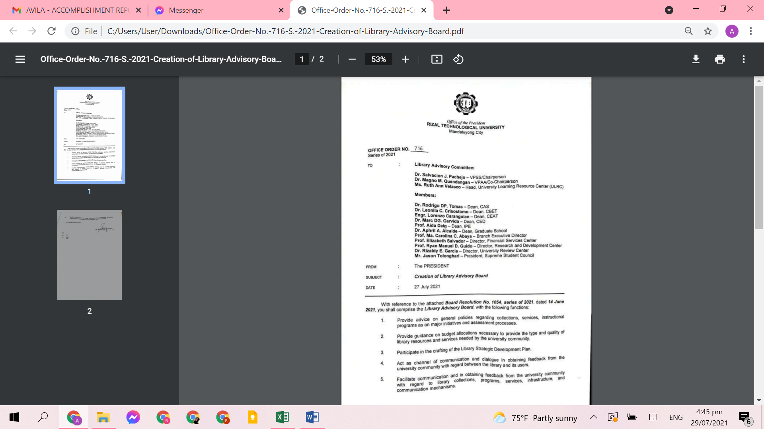

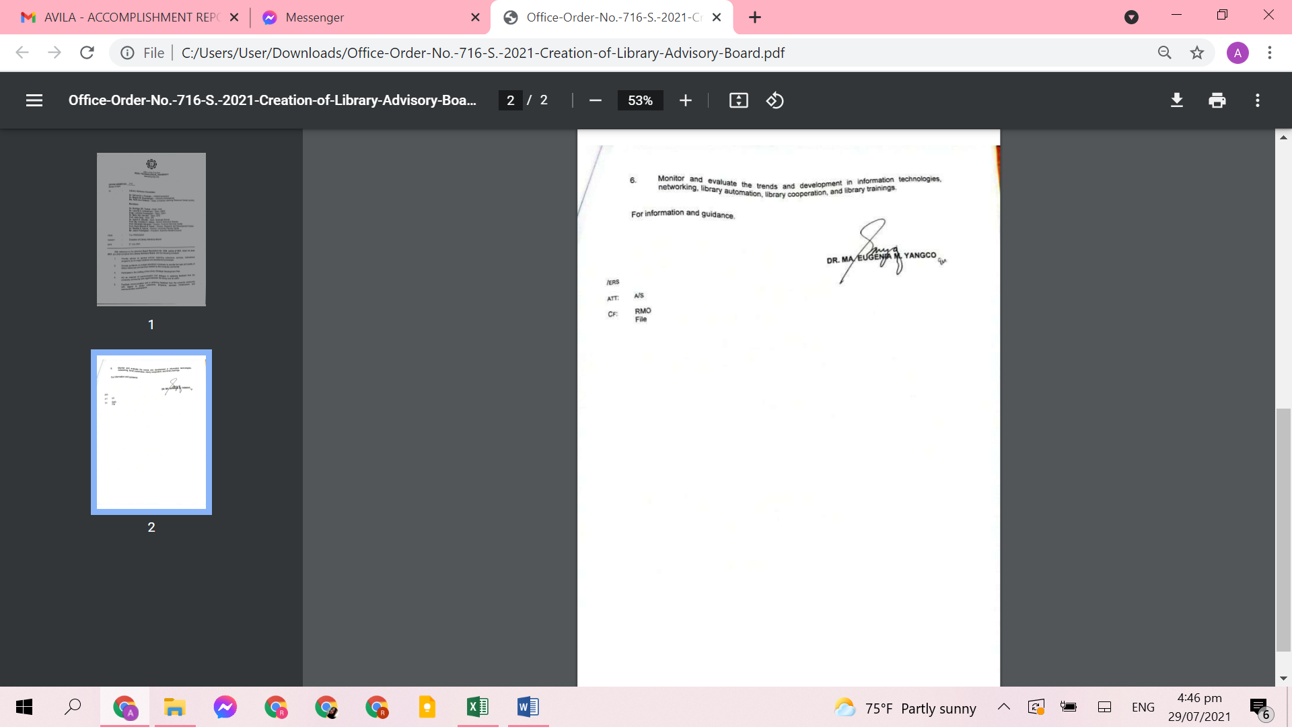

**Resolution No. 1054 Series 2021 Approving the Creation of Library Advisory Board**

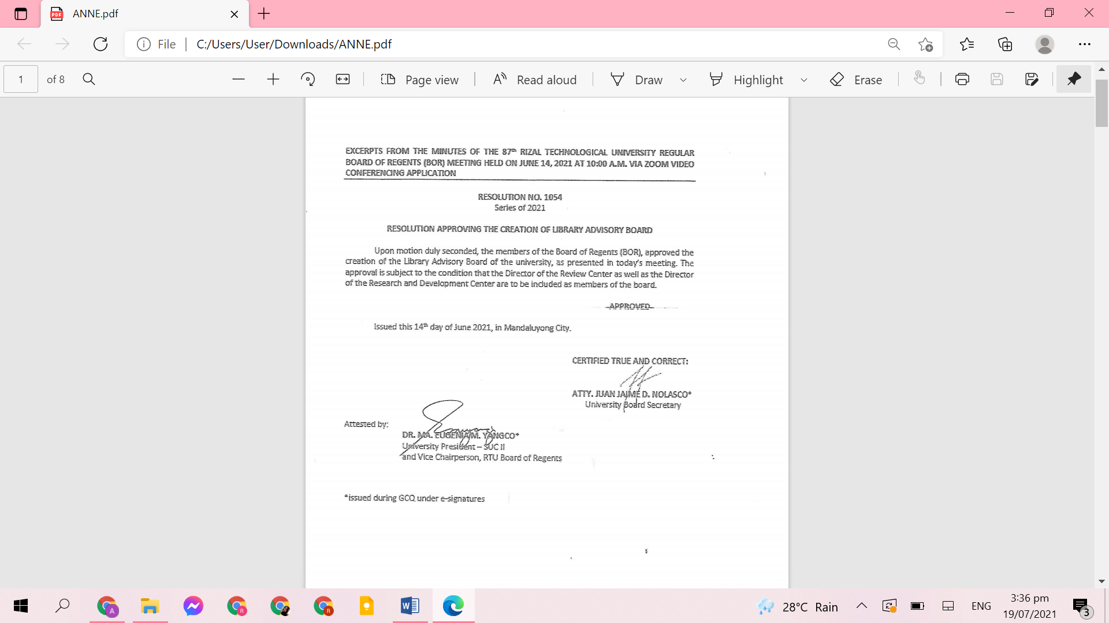

**Administrative Council Notice of Meeting on creation of Library Board Advisory**

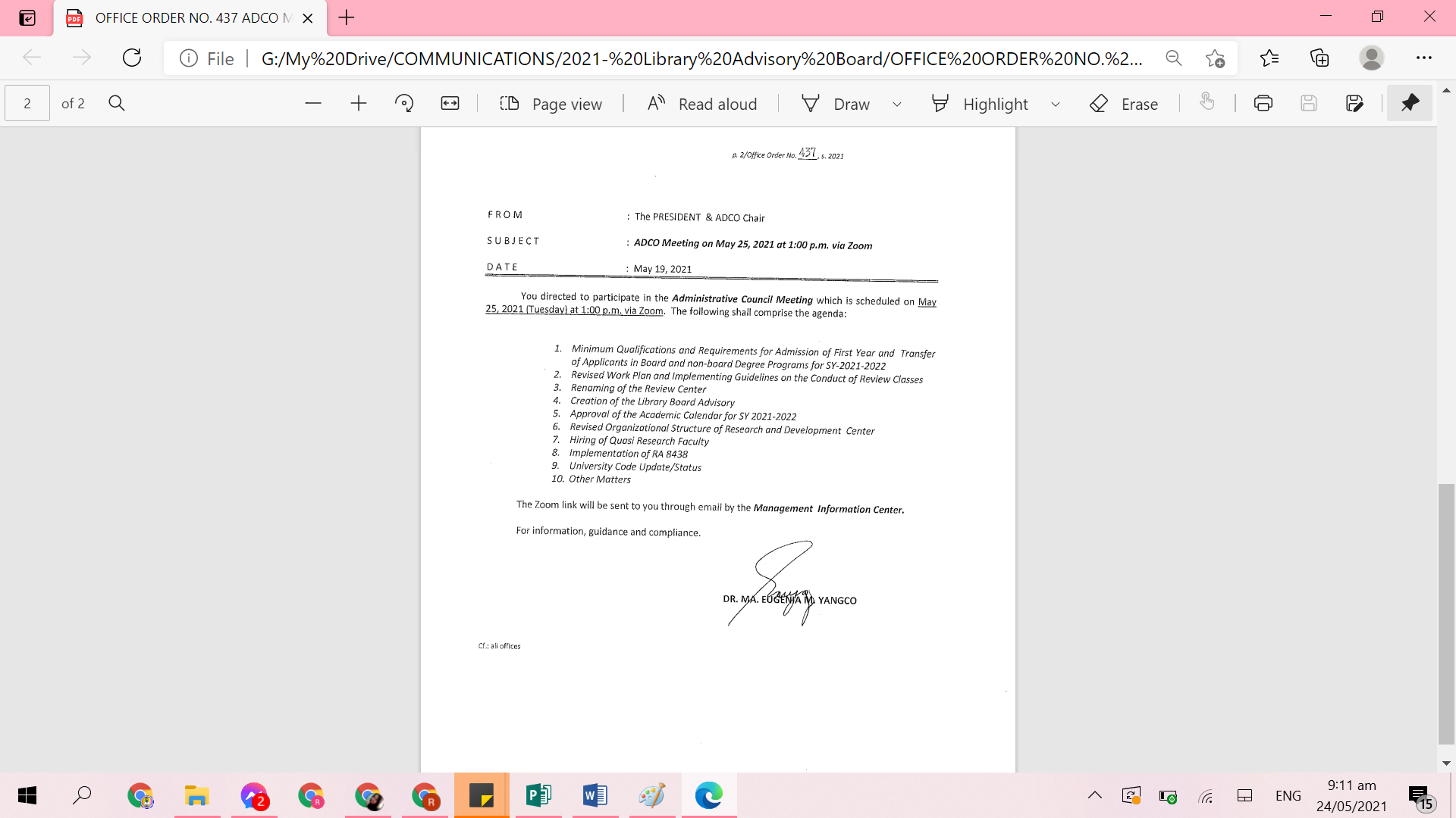

**Communication Letter of the University Librarian requesting Board of Regents Resolution for RTU Library Advisory Board**

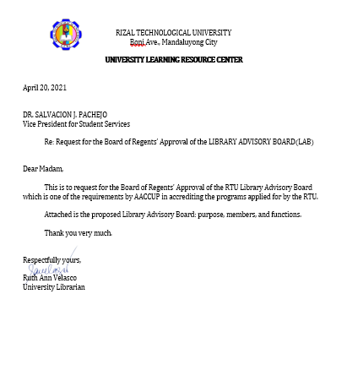

**Communication Letter of the University Librarian requesting the Endorsement of Department Heads for Library Advisory Committee**

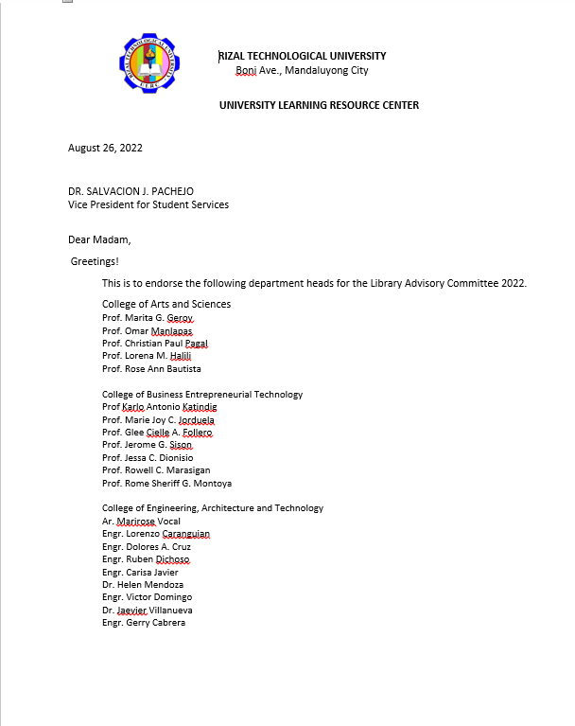

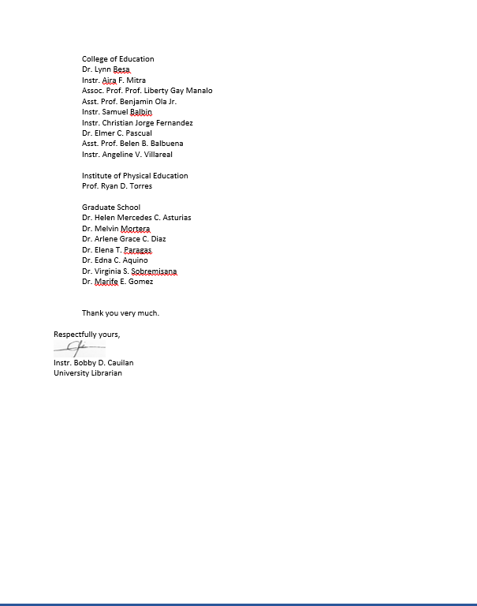

|  |  |  |  |
| --- | --- | --- | --- |
| RECOMMENDATIONS/  REMARKS | ACTION TAKEN BY HOST | % OF COMPLIANCE | EVIDENCES OF COMPLIANCE |
| 8. The administration may consider aligning the Library Department under the Vice President for Academic Affairs since the library’s main task is to support the curriculum or program. |  | **100%** | **1. BOR Resolution No. 1161 S.2022 Resolution approving the organizational structure of the University.** |

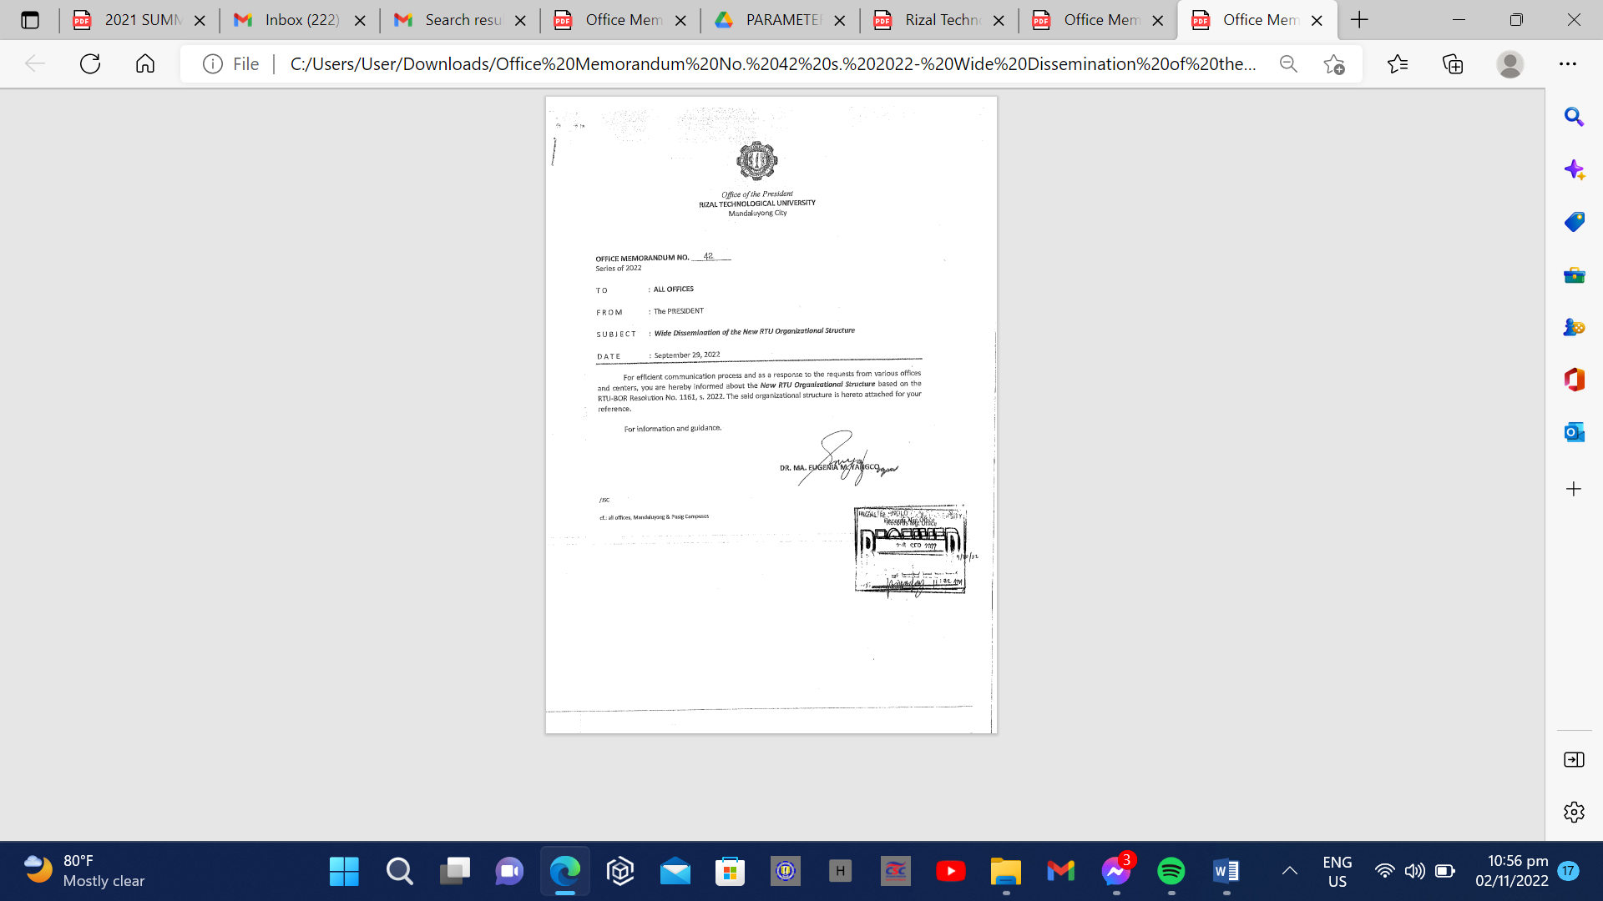

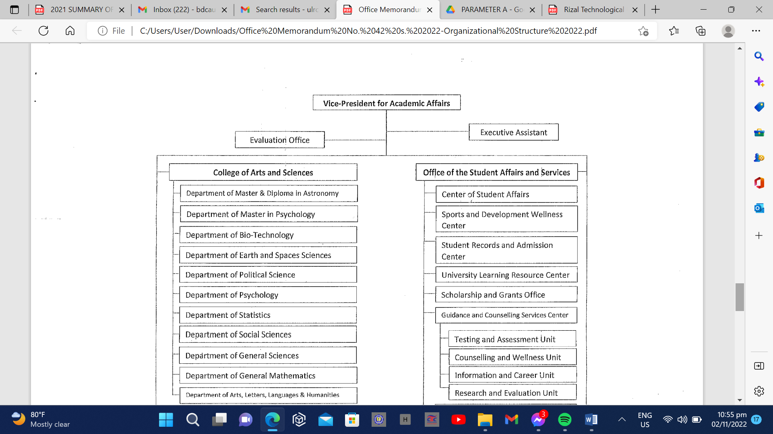

|  |  |  |  |
| --- | --- | --- | --- |
| RECOMMENDATIONS/  REMARKS | ACTION TAKEN BY HOST | % OF COMPLIANCE | EVIDENCES OF COMPLIANCE |
| 9. The administration may consider hiring more licensed Librarian to meet the Librarian ratio requirement of CHED and AACCUP. | **The University Librarian submitted a request letter for hiring of Librarians** | **95%** | 1. **Copy of Request Letter** |

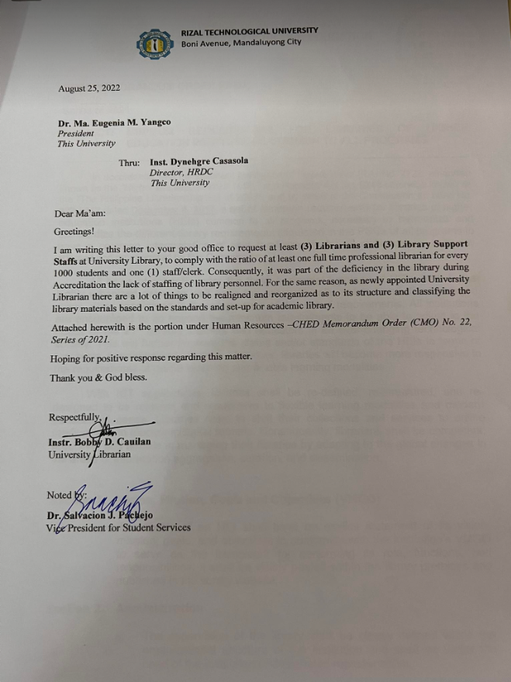

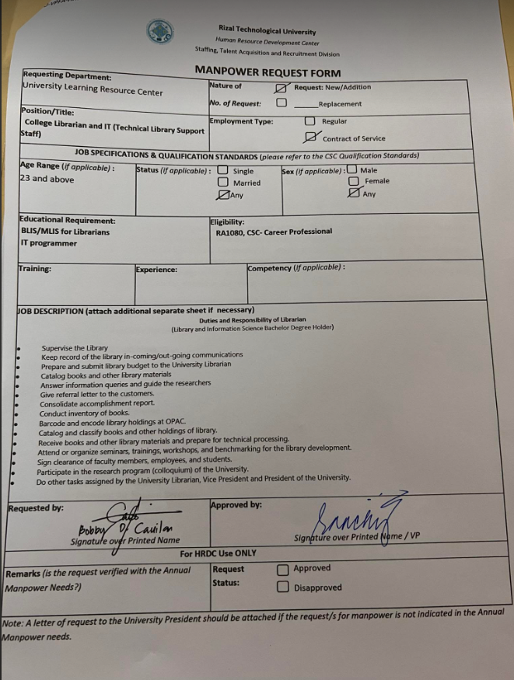

|  |  |  |  |
| --- | --- | --- | --- |
| RECOMMENDATIONS/  REMARKS | ACTION TAKEN BY HOST | % OF COMPLIANCE | EVIDENCES OF COMPLIANCE |
| 10. It is strongly suggested that the library’s website be reviewed and updated especially with increasing need for online information services. Consider including other features and links that may provide faster and easier access of information by users outside the library and the university. | **The University Librarian updated and reviewed the library’s website** | **95%** | 1. **Updated Library Website** |

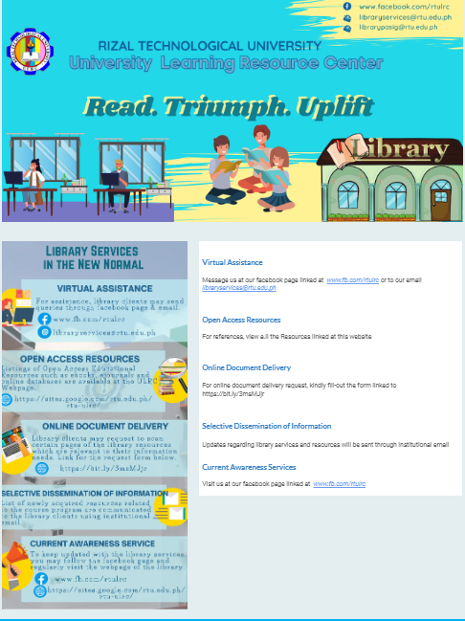

|  |  |  |  |
| --- | --- | --- | --- |
| RECOMMENDATIONS/  REMARKS | ACTION TAKEN BY HOST | % OF COMPLIANCE | EVIDENCES OF COMPLIANCE |
| 11. It is suggested that the library will prioritize the professional books per program. | **The University Librarian requested a acquisition of books for all the programs.** | **95%** | 1. **Purchased Order** 2. **PRIV** 3. **Professional books (Parameter C)** |

**PRE- REQUISITION AND ISSUE VOUCHER (PRIV)**

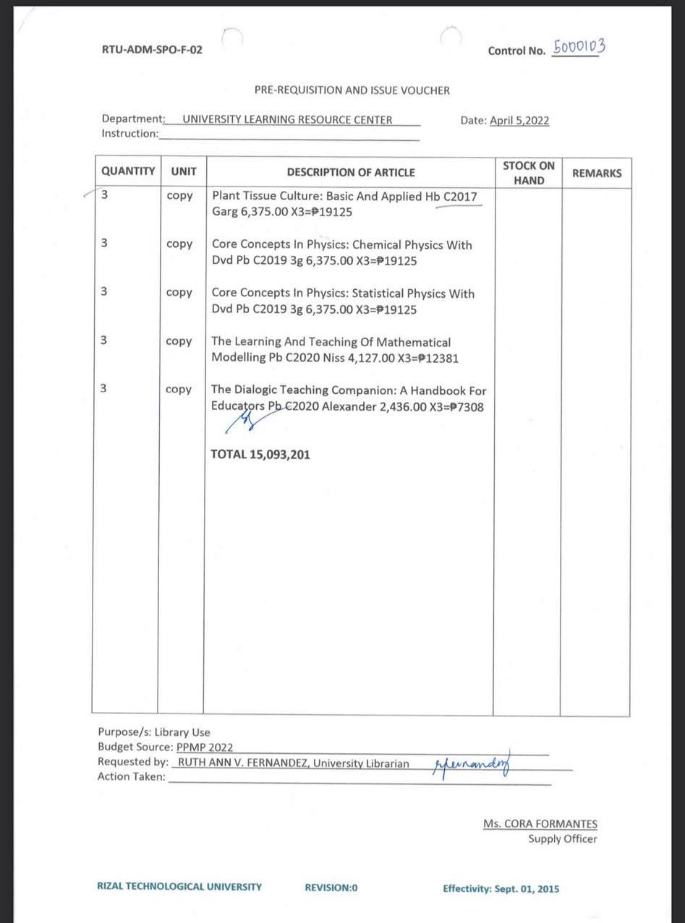

|  |  |  |  |
| --- | --- | --- | --- |
| RECOMMENDATIONS/  REMARKS | ACTION TAKEN BY HOST | % OF COMPLIANCE | EVIDENCES OF COMPLIANCE |
| 12. It is suggested that a research focusing on the evaluation of the effectiveness of personnel, collection, services, physical facilities and other programs of the library be conducted. This may serve as a basis for planning library development programs. | **The University Librarian presented in Research Colloquium** | **100%** | 1. **Certificates** 2. **Research Appointment Paper** |
|  |

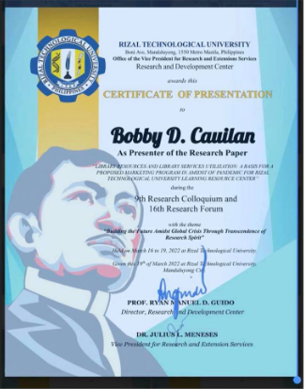

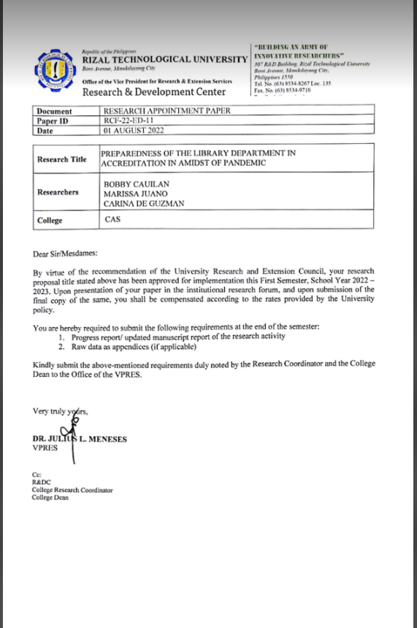

**LIBRARY RESEARCH**

|  |  |  |  |
| --- | --- | --- | --- |
| RECOMMENDATIONS/  REMARKS | ACTION TAKEN BY HOST | % OF COMPLIANCE | EVIDENCES OF COMPLIANCE |
| 13.Reiterating the previous recommendation to consider having a separate library building that can accommodate all library units and be easily accessible to all library patrons and house the growing collection including viewing room. | **The Infrastructure Management Office requested budget for the construction of the state-of-the-art library building approved by the NEDA.**  **The temporary main library is located at 2nd floor of SNAGAH while the construction of the University Library is on-process.** | **95%** | 1. **Evidence of budget for construction from the Infrastructure Management Office.** 2. **Library Floor Plan** |

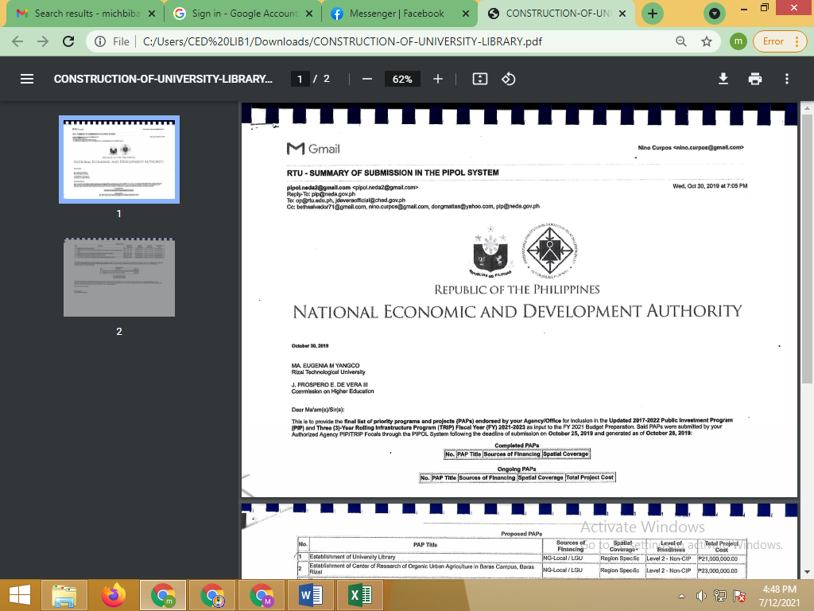

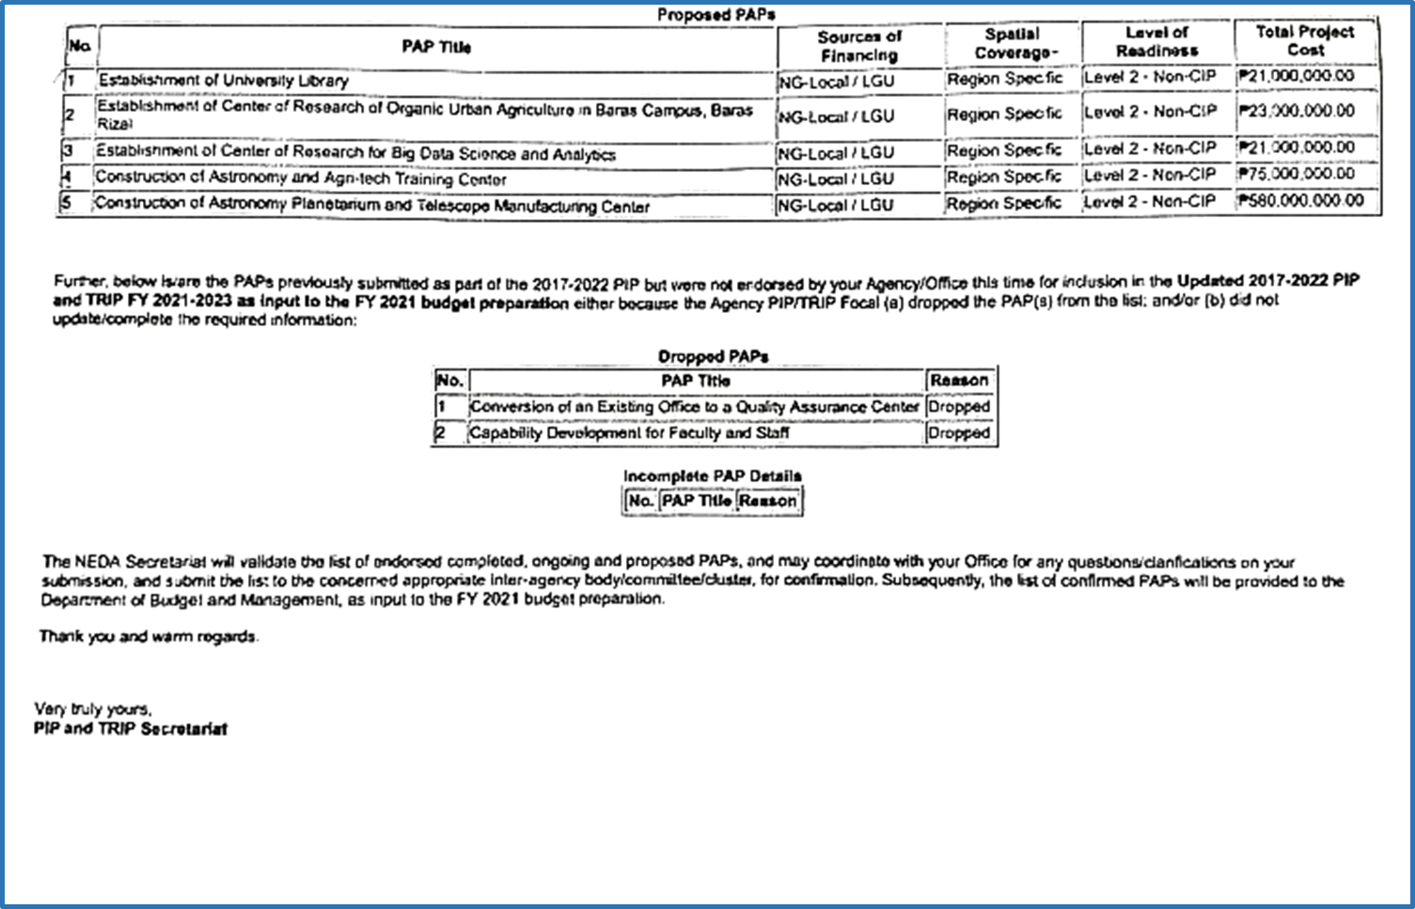

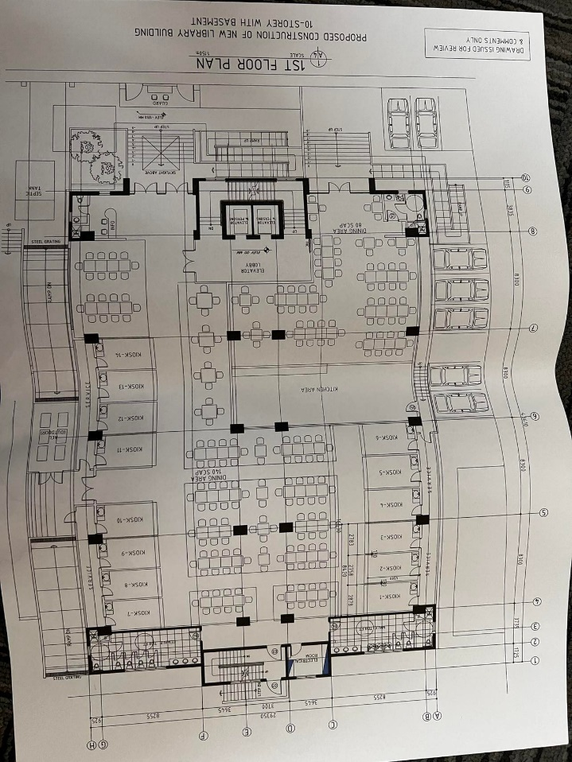

**LIBRARY FLOOR PLAN**

|  |  |  |  |
| --- | --- | --- | --- |
| RECOMMENDATIONS/  REMARKS | ACTION TAKEN BY HOST | % OF COMPLIANCE | EVIDENCES OF COMPLIANCE |
| 14. Yearly library fees paid by students may be allotted solely for the development of the library, i.e. its collection, services, facilities, and other programs as planned by the library in coordination with the required offices. | **The University Librarian utilized the Library fees through continuous Acquisition of library material’s** | **95%** | 1. **Purchase Order** 2. **PRIV** |

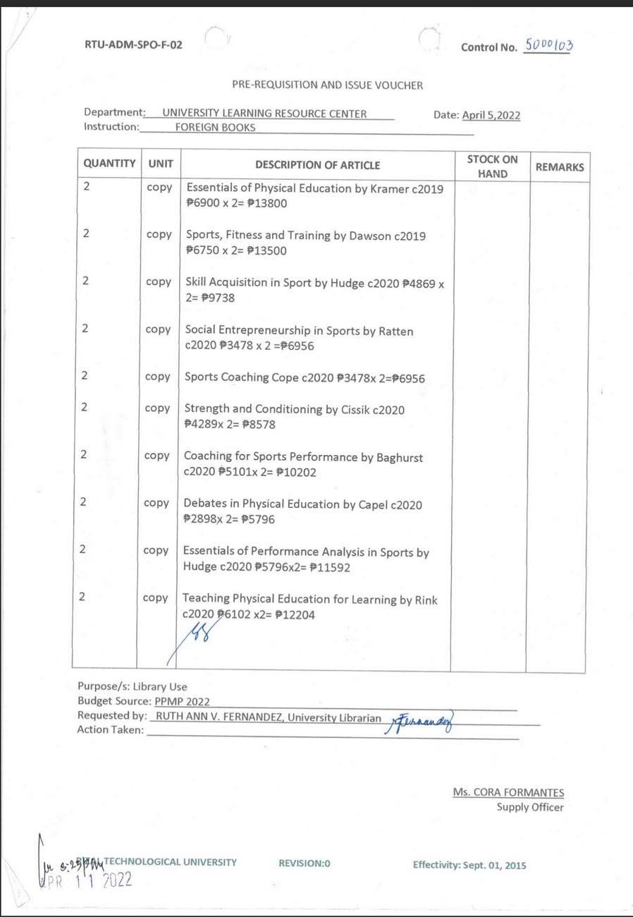



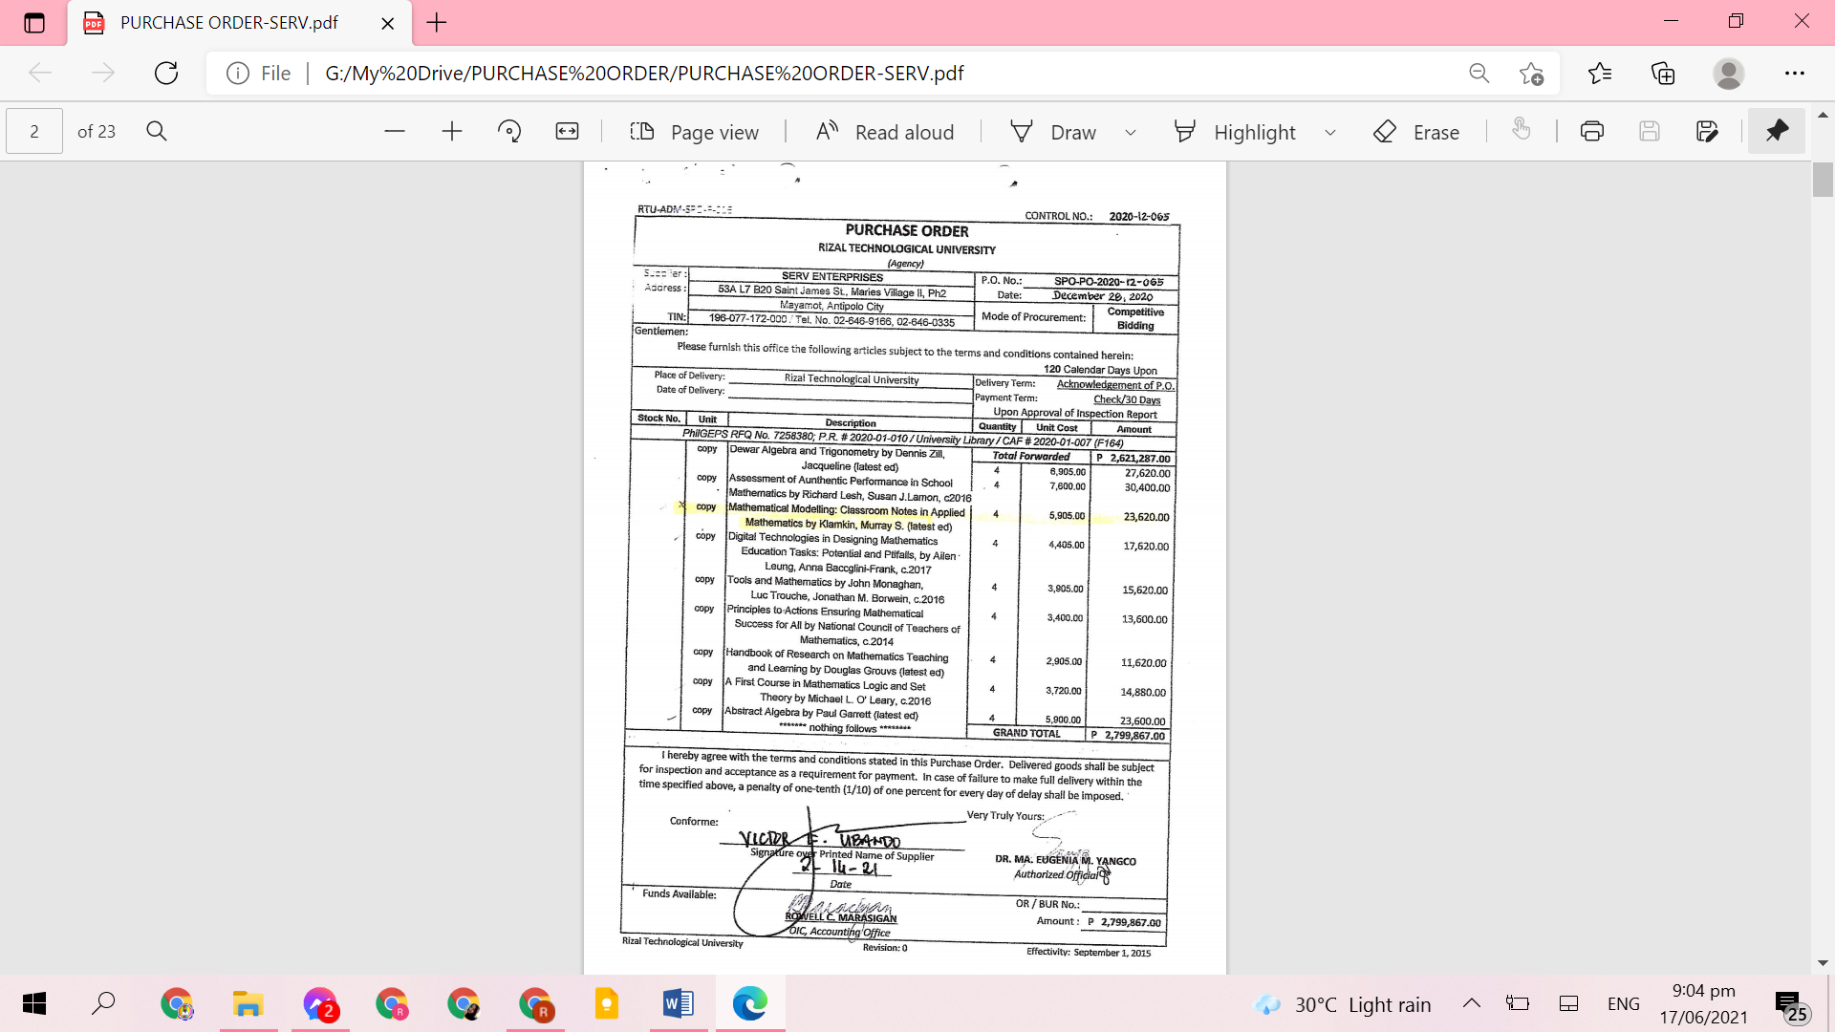

|  |  |  |  |
| --- | --- | --- | --- |
| RECOMMENDATIONS/  REMARKS | ACTION TAKEN BY HOST | % OF COMPLIANCE | EVIDENCES OF COMPLIANCE |
| 15. It is highly suggested that the library will acquire a security gate system to safeguard the library resources. | **The University Librarian drafted Development plan** | **95%** | 1. **PPMP** |

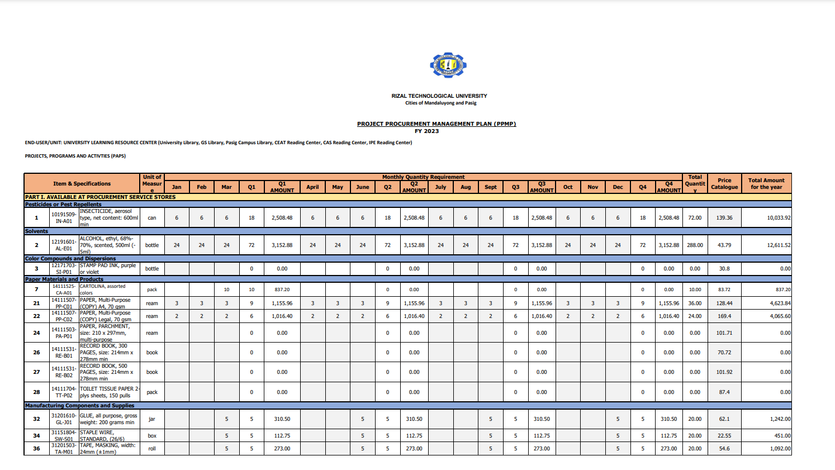

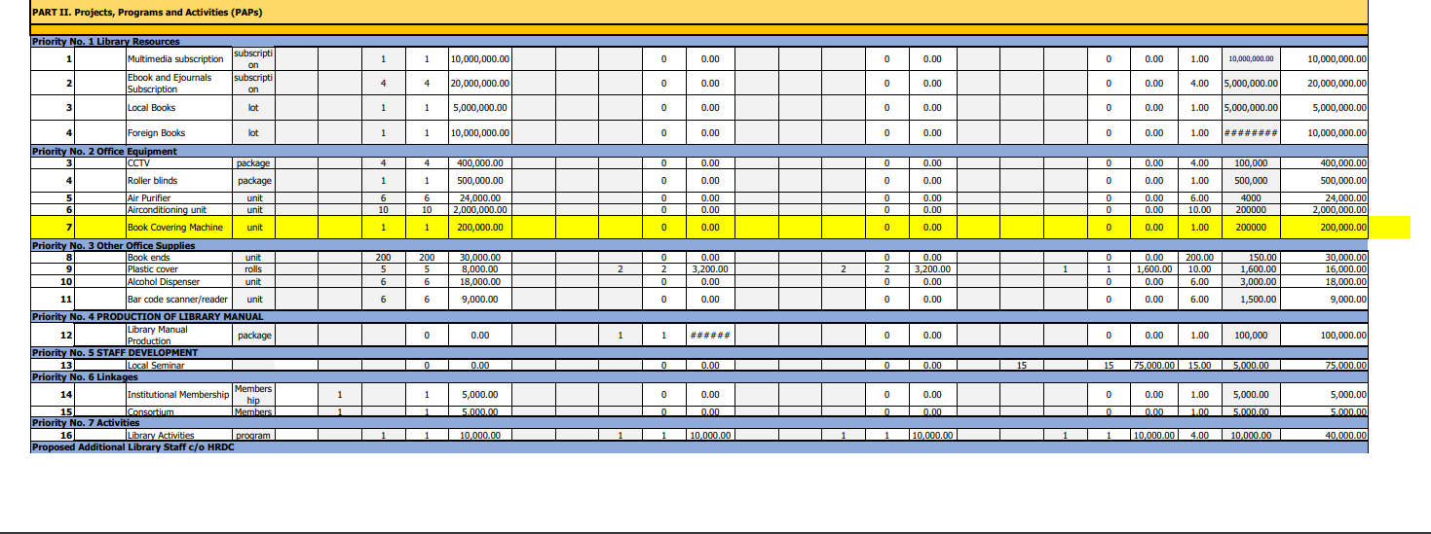

|  |  |  |  |
| --- | --- | --- | --- |
| RECOMMENDATIONS/  REMARKS | ACTION TAKEN BY HOST | % OF COMPLIANCE | EVIDENCES OF COMPLIANCE |
| 16. The library is encouraged to engage more in associations that are active in promoting the development of librarians and libraries. | **The University Librarian requested for membership to PLAI and PAARL** | **100%** | 1. **Request Letter for Membership** |

**Library PAARL Membership**

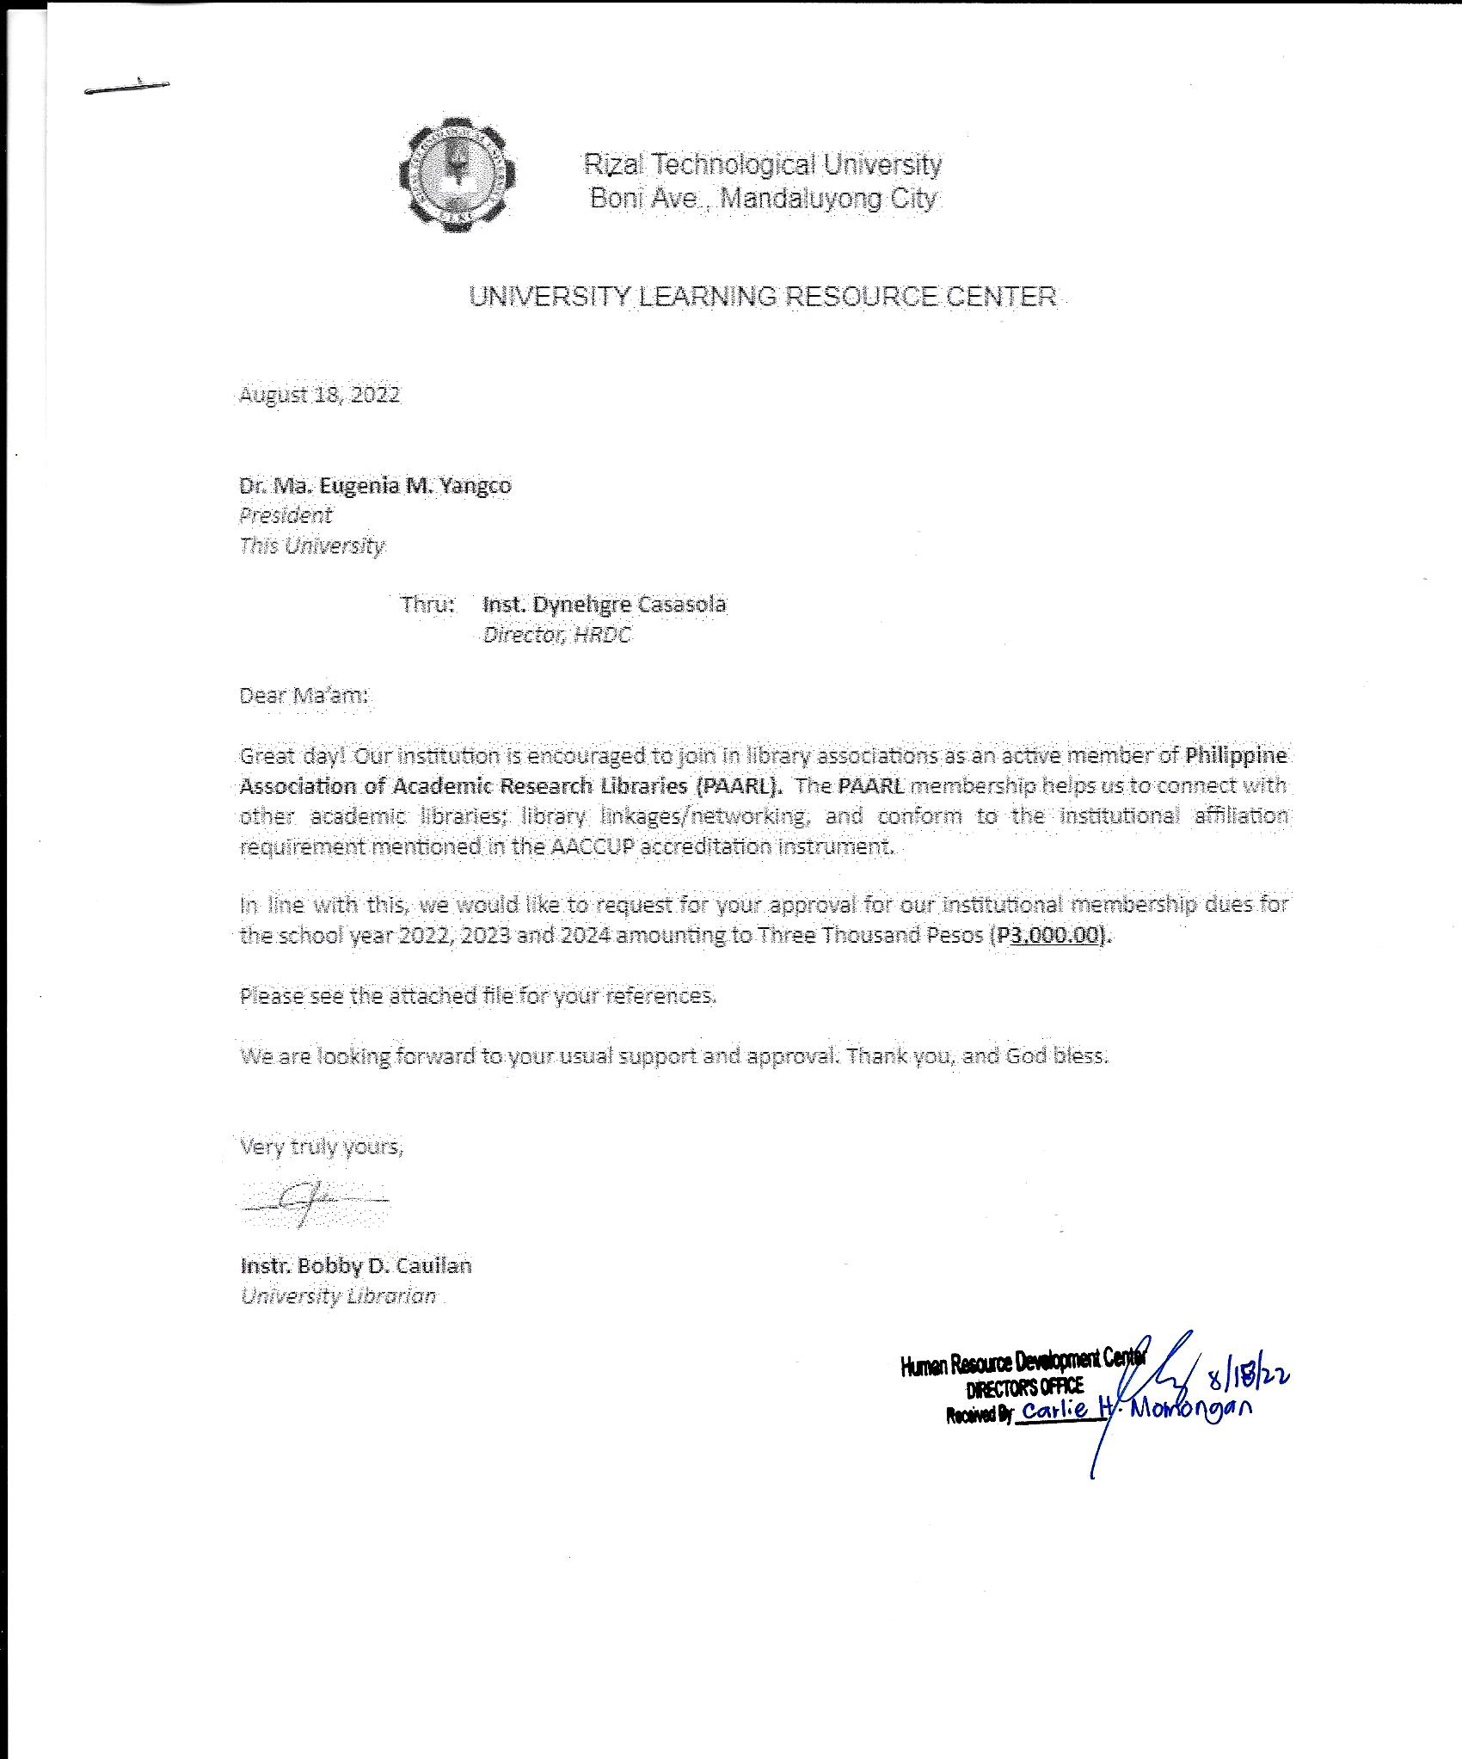

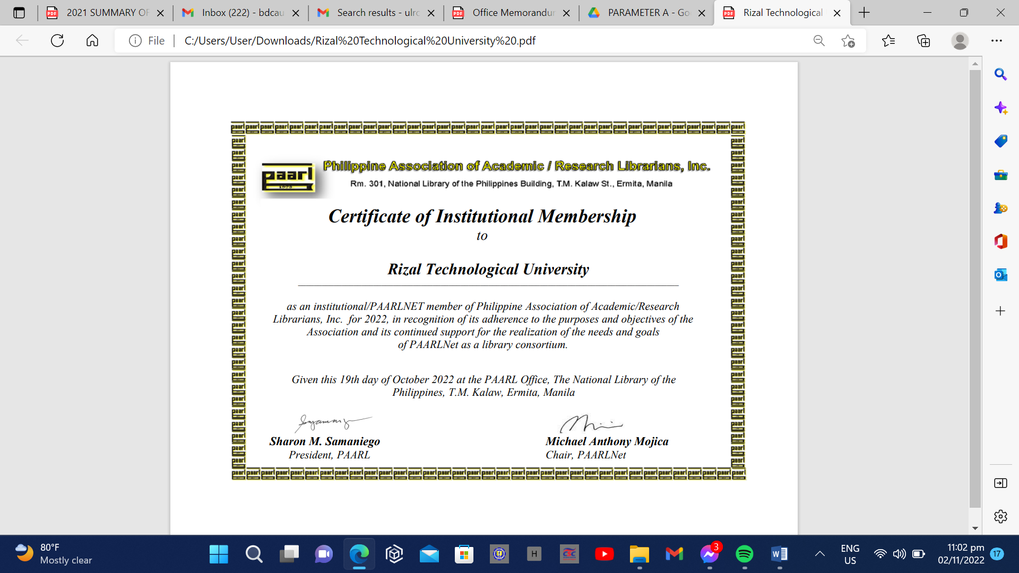

|  |  |  |  |
| --- | --- | --- | --- |
| RECOMMENDATIONS/  REMARKS | ACTION TAKEN BY HOST | % OF COMPLIANCE | EVIDENCES OF COMPLIANCE |
| 17. t is also suggested that attachments for accreditation purposes will include latest documents. |  | **100%** | **Attachments for Accreditation.** |